Marine Heatwaves in a warming Mediterranean Sea
  - A temporale analysis
Simon Oiry
Maria Laura Zoffoli
Christian Marchese
Laurent Barillé
2025-07-23
Abstract
TBD

1. Introduction
Marine heatwaves (MHWs) are discrete and prolonged periods of anomalously high sea temperatures that significantly exceed historical baseline conditions. Specifically, a marine heatwave is generally defined as an event lasting five or more consecutive days during which sea temperatures exceed the 90th percentile threshold based on a 30-year historical climatological period (Figure 1). These events can vary in terms of duration, intensity, and spatial extent, making a flexible yet rigorous approach necessary for accurate characterization and comparison.
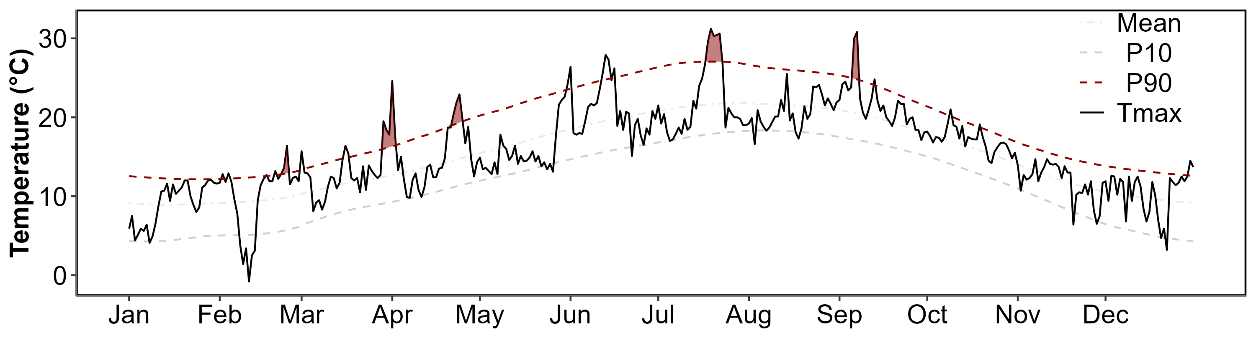
Figure 1: Exemple of heatwaves detection in Quiberon, France during the summer 2021
The importance of studying marine heatwaves arises from their profound ecological and socioeconomic impacts. They have been associated with widespread disruptions to marine ecosystems, including shifts in species distribution, local extinctions, significant mortality events, and changes in primary productivity. Such ecological disturbances subsequently affect fisheries, aquaculture, and biodiversity, highlighting the broad-reaching implications of these events.
The Mediterranean Sea, characterized as a climate change hotspot, has witnessed an increased frequency and intensity of marine heatwaves, especially over recent decades. Mediterranean MHWs often coincide with atmospheric heatwaves, further exacerbating their intensity and ecological impacts. Concurrent atmospheric and marine heatwaves amplify sea surface temperature anomalies, leading to intense ocean stratification and extensive ecological disruption, including mass mortalities of benthic invertebrates and seagrass decline.
In the Mediterranean, particularly in the Adriatic Sea, studies have documented variable responses of primary productivity to MHW events. In coastal and eutrophic regions, such as areas influenced by riverine nutrient input, MHWs have resulted in increased phytoplankton biomass. Conversely, offshore and oligotrophic regions typically exhibit reduced chlorophyll-a concentrations during heatwaves, indicating a potential decline in phytoplankton productivity. Such spatial heterogeneity emphasizes the complexity of ecological responses and underscores the importance of localized assessments.
Understanding marine heatwaves, particularly in sensitive regions like the Mediterranean Sea, is crucial for developing informed management strategies aimed at mitigating their ecological and socioeconomic consequences. This necessity is heightened by projections indicating further increases in MHW frequency, duration, and intensity, driven by ongoing climate change.

2. Material & Methods
Daily Sea Surface Temperature (SST) time series for the Mediterranean Sea, spanning from 1982 onwards, were obtained from the Copernicus Marine Environment Monitoring Service (CMEMS) platform (Copernicus, 2024; Embury et al., 2024; Pisano et al., 2016). Heatwave events were detected using the HeatwaveR package in R (Schlegel and Smit, 2018), adhering to the marine heatwave definition provided by Hobday et al. (2016) and Hobday et al. (2018).
To establish a reference climatology, the first 30 years of the dataset were utilized for each pixel within the Mediterranean Sea. Daily SST values were subsequently compared against this baseline climatology. A heatwave event was identified whenever the daily SST exceeded the 90th percentile of the corresponding climatological distribution. Additionally, consecutive events separated by fewer than two days were merged and treated as a single continuous heatwave event.
Results are presented as annual maps of key heatwave metrics: the total number of days classified as heatwave, the number of distinct heatwave events, and the cumulative intensity of these events, defined as the sum of daily SST exceedances above the climatological 90th percentile threshold.
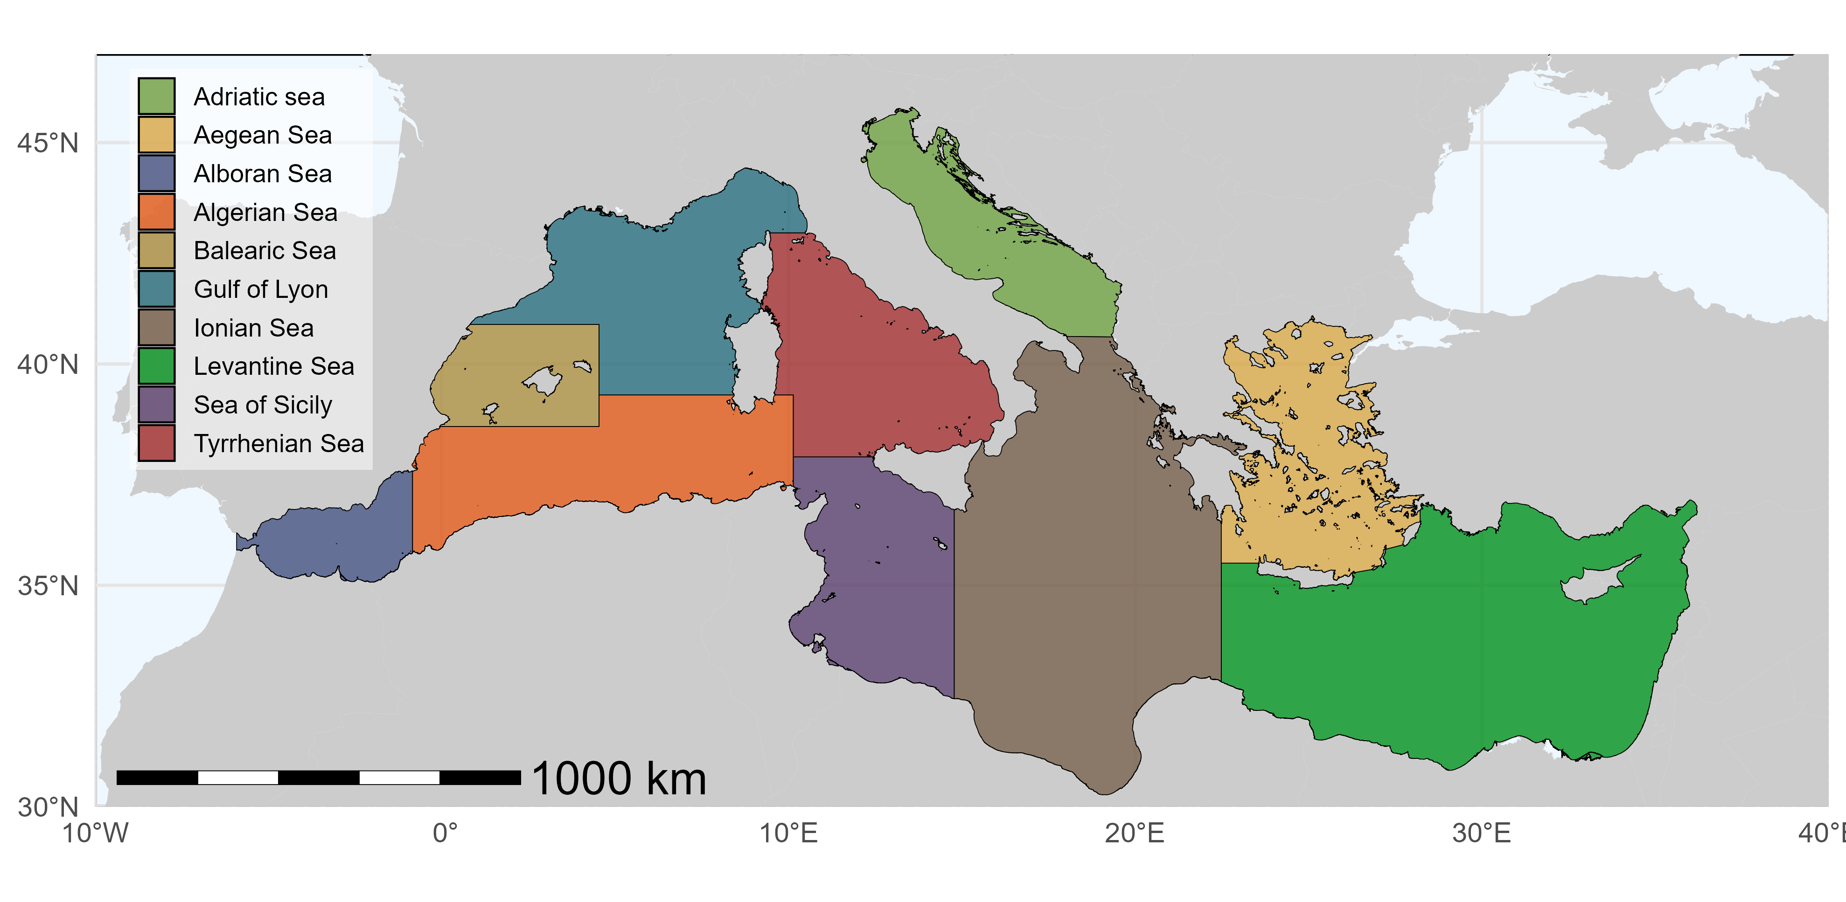
Figure 2: Region of Mediterranean Sea as definied by Marine Strategy Framework Directive.
HW metrics where summerised for each regions of the Mediterranean sea, following the nomenclature defined by the Marine Strategy Framework Directive (MSFD, Figure 2).

3. Results

3.1 SST phenology
[1] 0.3825375
Yearly SST time series for each of the 10 Mediterranean sub-regions are presented in Figure 3. Across all regions, periods of minimum and maximum temperatures occur synchronously, with minima in February–March and maxima in July–August. Overall, every sub-region exhibits higher SST values in 2024 compared to 1982. The most significant increase in summer temperature maxima is observed in Adriatic sea, with a warming rate of 0.63 °C per decade. Similarly, the most substantial increase in winter temperature minima occurs in Aegean Sea showing a warming rate of 0.4 °C per decade.
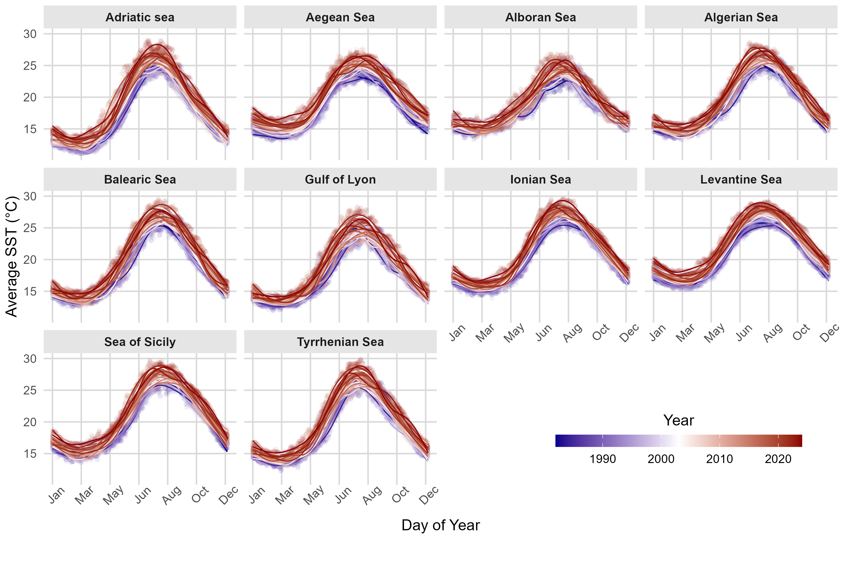
Figure 3: Seasonal cycle of average sea surface temperature (°C) for ten Mediterranean sub-regions. In each panel, semi-transparent points are daily SST average of the region and solid lines are GAM smooths of SST against day-of-year.
Dates on which SST minima and maxima occur remain generally consistent over the study period for most regions (Figure 4). However, shifts are observed in some areas: the winter temperature minimum in Levantine Sea occurs progressively earlier by 3.32 days per decade, while in Balearic Sea it occurs progressively later by 3.76 days per decade. Regarding the timing of maximum SST, two regions stand out: Adriatic sea and Aegean Sea both show an earlier occurrence of their annual temperature maxima by 2.41 and 1.58 days per decade, respectively.
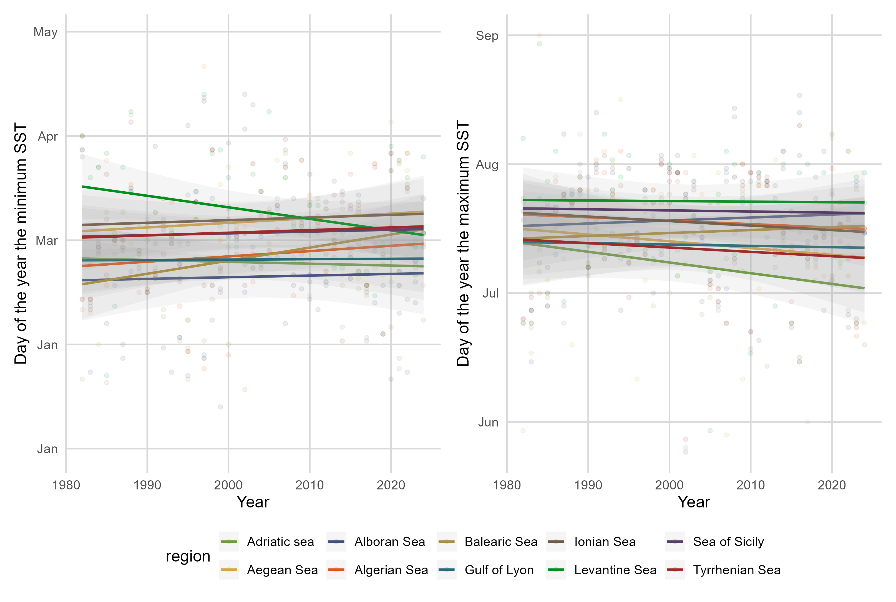
Figure 4: Trends in the timing of annual minimum (left panel) and maximum (right panel) Sea Surface Temperature (SST) across ten Mediterranean sub-regions from 1982 to 2024. Linear regression lines and 95% confidence intervals illustrate the shifts in timing (day of the year), highlighting regions with earlier or later occurrences of annual temperature extremes over the studied period.
Figure 5 (left) shows the start date of the warm season in all subregions of the Mediterranean Sea. The warm season begins when the daily SST exceeds the 75th percentile (p75) of the subregion’s SST for five consecutive days. A downward trend is evident across all subregions, indicating that the warm season now starts on average 5.66 days earlier per decade. The Levantine Sea shows the greatest advancement in onset, at 8.23 days per decade.
Regarding the end of the warm season, a consistent delay is observed across all subregions, with the season ending on average 3.69 days later per decade (Figure 5 middle). Two regions stand out—Levantine Sea and Aegean Sea— showing shifts of 7.01 and 5.33 days per decade, respectively.
Figure 5 (right) shows the length of the warm season, defined as the interval between its end and start dates. Across the Mediterranean basin, the warm season is lengthening by 9.35 days per decade on average. All subregions exhibit this trend, except for Levantine Sea and Aegean Sea, which show increases of 15.24 and 11.48 days per decade, respectively.
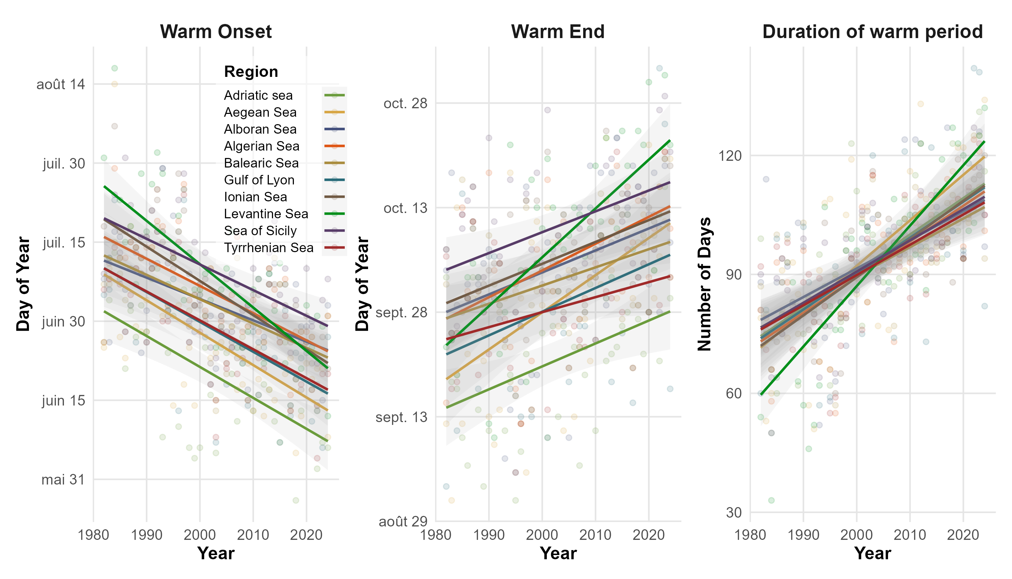
Figure 5: Trends in the timing and duration of the warm season across ten Mediterranean sub-regions. Left panel (“Warm Onset”) shows the day of year when SST exceeds the p75 of temperature for more than 5 concecutive days, each year; central panel (“Warm End”) shows the day of year when SST falls bellow the p75 for more than 5 concecutive days; right panel (Duration of warm period) shows the amount of days between the start and the end of the warm season. Semi-transparent points are the annual onset/end dates for each region, and colored lines are per-region linear fits with 95% confidence bands. Downward slopes on the left indicate progressively earlier warm‐season starts, while upward slopes on the right indicate progressively later warm‐season terminations.
The thermic amplitude is defined as the difference between the minimum winter SST and the maximum summer SST. The subregion with the smallest thermal amplitude is Alboran Sea, averaging just 10.82°C between summer peaks and winter troughs. By contrast, Adriatic sea exhibits the largest thermal amplitude in the Mediterranean Sea, at 14.94. Across the entire basin, there is an increasing trend in thermic amplitude, averaging 0.17°C per decade. The region with the most pronounced rise is Adriatic sea where amplitude grows by 0.32°C each decade. This divergence stems from summer temperatures rising about 38 % faster than winter temperatures across the basin.
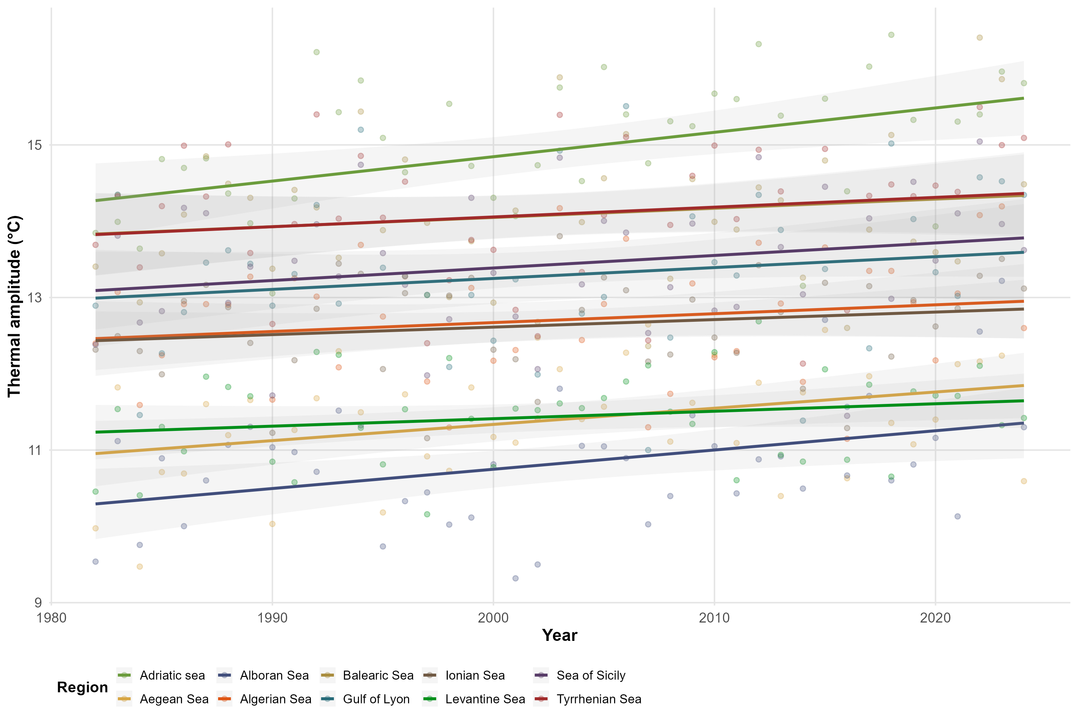
Figure 6: Trends in the timing and duration of the warm season across ten Mediterranean sub-regions. Left panel (“Warm Onset”) shows the day of year when SST exceeds the p75 of temperature for more than 5 concecutive days, each year; central panel (“Warm End”) shows the day of year when SST falls bellow the p75 for more than 5 concecutive days; right panel (Duration of warm period) shows the amount of days between the start and the end of the warm season. Semi-transparent points are the annual onset/end dates for each region, and colored lines are per-region linear fits with 95% confidence bands. Downward slopes on the left indicate progressively earlier warm‐season starts, while upward slopes on the right indicate progressively later warm‐season terminations.

3.2 Heatwaves by regions

3.3 Heatwaves Pixel per Pixels

3.3.1 Number of Event per year

3.3.2 Intensity

3.3.3 Duration
Copernicus, 2024. Copernicus open access hub.
Embury, O., Merchant, C.J., Good, S.A., Rayner, N.A., Høyer, J.L., Atkinson, C., Block, T., Alerskans, E., Pearson, K.J., Worsfold, M., McCarroll, N., Donlon, C., 2024. Satellite-based time-series of sea-surface temperature since 1980 for climate applications. Scientific Data 11, 326. https://doi.org/10.1038/s41597-024-03147-w
Hobday, A.J., Alexander, L.V., Perkins, S.E., Smale, D.A., Straub, S.C., Oliver, E.C., Benthuysen, J.A., Burrows, M.T., Donat, M.G., Feng, M., others, 2016. A hierarchical approach to defining marine heatwaves. Progress in oceanography 141, 227–238.
Hobday, A.J., Oliver, E.C., Gupta, A.S., Benthuysen, J.A., Burrows, M.T., Donat, M.G., Holbrook, N.J., Moore, P.J., Thomsen, M.S., Wernberg, T., others, 2018. Categorizing and naming marine heatwaves. Oceanography 31, 162–173.
Pisano, A., Nardelli, B.B., Tronconi, C., Santoleri, R., 2016. The new mediterranean optimally interpolated pathfinder AVHRR SST dataset (1982–2012). Remote Sensing of Environment 176, 107–116. https://doi.org/10.1016/j.rse.2016.01.019
Schlegel, R.W., Smit, A.J., 2018. heatwaveR: A central algorithm for the detection of heatwaves and cold-spells. Journal of Open Source Software 3, 821. https://doi.org/10.21105/joss.00821

