Characterization of Intertidal Vegetation on European Coasts Using Multi-Scale Remote Sensing in Response to Natural and Anthropogenic Pressures
Simon Oiry
2025-03-11
Abstract
To Be Written
Table of contents

Preface
This PhD work was carried out at Nantes University between 2022 and 2024, within the “Remote Sensing, Benthic Ecology and Ecotoxicology” (RSBE²) team of the Institute of Marine Substances and Organisms (ISOMer). This thesis was funded by the Ministry of Research and Higher Education and supervised by the doctoral school “Plant, Animal, Food, Sea, Environment” (VAAME).

Scientific papers
- Brunier, G., Oiry, S., Gruet, Y., Dubois, S. F., & Barillé, L. (2022). Topographic Analysis of Intertidal Polychaete Reefs (Sabellaria alveolata) at a Very High Spatial Resolution. Remote Sensing, 14(2), 307. https://doi.org/10.3390/rs14020307
- Brunier, G., Oiry, S., Lachaussée, N., Barillé, L., Le Fouest, V., & Méléder, V. (2022). A Machine-Learning Approach to Intertidal Mudflat Mapping Combining Multispectral Reflectance and Geomorphology from UAV-Based Monitoring. Remote Sensing, 14(22), 5857. https://doi.org/10.3390/rs14225857
- Zoffoli, M.L., Gernez, P., Oiry, S., Godet, L., Dalloyau, S., Davies, B.F.R. and Barillé, L. (2023), Remote sensing in seagrass ecology: coupled dynamics between migratory herbivorous birds and intertidal meadows observed by satellite during four decades. Remote Sens Ecol Conserv, 9: 420-433. https://doi.org/10.1002/rse2.319
- Davies, B. F. R., Gernez, P., Geraud, A., Oiry, S., Rosa, P., Zoffoli, M. L., & Barillé, L. (2023). Multi- and hyperspectral classification of soft-bottom intertidal vegetation using a spectral library for coastal biodiversity remote sensing. Remote Sensing of Environment, 290, 113554. https://doi.org/10.1016/j.rse.2023.113554
- Román, A., Prasyad, H., Oiry, S., Davies, B. F. R., Brunier, G., & Barillé, L. (2023). Mapping intertidal oyster farms using unmanned aerial vehicles (UAV) high-resolution multispectral data. Estuarine, Coastal and Shelf Science, 291, 108432. https://doi.org/10.1016/j.ecss.2023.108432
- Nurdin, N., Alevizos, E., Syamsuddin, R., Asis, H., Zainuddin, E. N., Aris, A., Oiry, S., Brunier, G., Komatsu, T., & Barillé, L. (2023). Precision Aquaculture Drone Mapping of the Spatial Distribution of Kappaphycus alvarezii Biomass and Carrageenan. Remote Sensing, 15(14), 3674. https://doi.org/10.3390/rs15143674
- Davies, B. F. R., Oiry, S., Rosa, P., Zoffoli, M. L., Sousa, A. I., Thomas, O. R., Smale, D. A., Austen, M. C., Biermann, L., Attrill, M. J., & others. (2024). A sentinel watching over inter-tidal seagrass phenology across Western Europe and North Africa. Communications Earth & Environment, 5(1), 382. https://doi.org/10.1038/s43247-024-382
- Davies, B. F. R., Oiry, S., Rosa, P., Zoffoli, M. L., Sousa, A. I., Thomas, O. R., Smale, D. A., Austen, M. C., Biermann, L., Attrill, M. J., Roman, A., Navarro, G., Barillé, A.-L., Harin, N., Clewley, D., Martinez-Vicente, V., Gernez, P., & Barillé, L. (2024). Intertidal seagrass extent from Sentinel-2 time-series show distinct trajectories in Western Europe. Remote Sensing of Environment, 312, 114340. https://doi.org/10.1016/j.rse.2024.114340
- Román, A., Oiry, S., Davies, B. F. R., Rosa, P., Gernez, P., Tovar-Sánchez, A., Navarro, G., Méléder, V., & Barillé, L. (2024). Mapping intertidal microphytobenthic biomass with very high-resolution remote sensing imagery in an estuarine system. Science of The Total Environment, 955, 177025. https://doi.org/10.1016/j.scitotenv.2024.177025
- Oiry, S., Davies, B. F. R., Sousa, A. I., Rosa, P., Zoffoli, M. L., Brunier, G., Gernez, P., & Barillé, L. (2024). Discriminating Seagrasses from Green Macroalgae in European Intertidal Areas Using High-Resolution Multispectral Drone Imagery. Remote Sensing, 16(23), 4383. https://doi.org/10.3390/rs16234383
- Barillé, L., Paterson, I. L. R., Oiry, S., Aris, A., Cook-Cottier, E. J., & Nurdin, N. (2025). Variability of Kappaphycus alvarezii cultivation in South-Sulawesi (Indonesia) related to the monsoon shift: Water quality, growth and colour quantification. Aquaculture Reports, 40, 102557. https://doi.org/10.1016/j.aqrep.2024.102557

Oral presentation
- Precision aquaculture drone mapping of the spatial distribution of Kappaphycus alvarezii biomass and carrageenan (August 2023) ; 8th European Phycological Congress, Brest, France.
- Effect of Marine and Atmospheric Heatwaves on Reflectance and Pigment Composition of Intertidal Zostera noltei (February 2025) ; BioSpace25 - Biodiversity insight from Space, Frascati, Italy.

1. Introduction & Overview

1.1 General Introduction

1.1.1 Coastal Environment

1.1.2 Remote sensing applied to Coastal environments

1.2 Overview
Discriminating green macroalgae from seagrasses throught remote sensing poses significant challenges due to their overlapping spectral signatures and similar pigment compositions, particularly in the visible and near-infrared spectral regions. Both vegetation types share key pigments such as chlorophyll-a and carotenoids, which lead to analogous reflectance patterns. This similarity complicates their differentiation using conventional remote sensing techniques, especially when these species coexist within heterogeneous habitats. Despite these challenges, advances in spectral resolution and machine learning provide avenues for improved classification.
Chapter 2 establishes the foundation by presenting a proof-of-concept study that demonstrates the feasibility of discriminating green macroalgae from seagrasses in intertidal zones using remote sensing. By employing both multi- and hyperspectral datasets, the study elucidates the specific wavelengths and spectral resolutions that maximize classification accuracy, showcasing the potential of remote sensing for detailed habitat mapping.
Building upon the proof of concept, Chapter 3 focuses on the development of a robust algorithm capable of automating the discrimination of green macrophytes in heterogeneous intertidal habitats. Utilizing high-resolution multispectral drone imagery and advanced machine learning techniques, this chapter addresses the spatial complexity of these environments. The algorithm’s validation across diverse geographic and ecological settings ensures its applicability beyond the initial study sites. This advancement underscores the critical role of cutting-edge remote sensing technologies in ecological monitoring.
In Chapter 4, the methodology evolves to include red macroalgae, specifically targeting the invasive species Gracilaria vermiculophylla. By adapting the algorithm from Chapter 3, this study extends its application to a different taxonomic group, demonstrating the flexibility and scalability of the approach. Additionally, this chapter integrates LiDAR-based topographical data to examine the relationship between habitat characteristics and macroalgal distribution. The insights gained from mapping and modeling the spatial dynamics of G. vermiculophylla provide valuable implications for managing invasive species and conserving native biodiversity.
Finally, Chapter 5 examines the physiological impacts of environmental stressors, specifically marine and atmospheric heatwaves, on seagrass reflectance. Through controlled laboratory experiments and field validations, this chapter highlights the spectral responses of Zostera noltei under heatwave conditions. Well-established spectral indices such as the NDVI and GLI are employed, and a new index, the Seagrass Heat Shock Index (SHSI), is developed to specifically identify heatwave-impacted seagrasses. These indices provide metrics to detect and quantify stress-induced changes. These findings emphasize the role of remote sensing in assessing the resilience and vulnerability of intertidal ecosystems under climate change.

2. Hyperspectral classification of intertidal vegetation for coastal biodiversity

2.1 Introduction
Soft-bottom intertidal ecosystems support a diversity of habitats (seagrass meadows, honeycomb worm reefs, oyster reefs, mudflats) and biological communities worldwide (Mouritsen and Poulin 2002; Van Der Maarel 2003; Murray et al. 2019). The richness and diversity these habitats contain help to provide numerous ecosystem services, such as protection against coastal erosion, carbon regulation, oxygen production, seasonal habitat for migratory birds (Zoffoli et al. 2022), and reserves and nurseries for fisheries (Gardner and Finlayson 2018). However, the significant roles of intertidal areas for biodiversity and the ecosystem services they provide are not universally known (R. K. F. Unsworth et al. 2019; R. K. F. Unsworth, Nordlund, and Cullen-Unsworth 2019; R. K. Unsworth et al. 2022; Reddin et al. 2022). Like the majority of coastal ecosystems worldwide, intertidal areas are exposed and vulnerable to anthropogenic pressures, particularly more so due to their closer proximity to potentially destructive human activity (Murray et al. 2019; Green et al. 2021). Global warming, sea-level rise and the rising frequency of extreme climatic events lead to a reduction of their surface (Masson-Delmotte et al. 2021), and to a diminution of their capability to recover from perturbations (Schiel et al. 2021). The effects of climate change impact intertidal habitats inconsistently; declines of certain species and the proliferation of others (Bryndum-Buchholz et al. 2019). Intertidal areas are also directly degraded by human activities, such as coastal urbanization (Momota and Hosokawa 2021), use of various biochemical contaminants (Durou et al. 2007; Hope et al. 2021), eutrophication (Cardoso et al. 2004), land reclamation (Sedano et al. 2021), and shellfish farming (Garmendia et al. 2021). These pressures impact intertidal biodiversity (Beltrand et al. 2022) and the ecosystem services it provides (Gardner and Finlayson 2018; Brondízio et al. 2019).
To reduce these impacts and improve the protection of intertidal areas, several measures have been implemented over the past decades in Europe, such as the Water Framework Directive (WFD, Parliament and Council 2001), and the Marine Strategy Framework Directive (MSFD, Parliament and Council 2008). However, according to the Intergovernmental Science-Policy Platform on Biodiversity and Ecosystem Services (IPBES, Brondízio et al. 2019), current efforts are insufficient to reach the objectives of ecosystem conservation and sustainable exploitation. The ecological status of many intertidal areas have never been evaluated, with many areas uncharacterised. Even in documented areas, there are many socio-environmental challenges to implementing efficient protection and sustainable exploitation (R. K. F. Unsworth et al. 2019). Providing updated and accurate maps of intertidal areas is a prerequisite to addressing such challenges (McKenzie et al. 2020). However, the traditional methods for mapping rely on field surveys to estimate species abundance, biomass and habitat surface, which are time-consuming and labor-intensive (Nijland, Reshitnyk, and Rubidge 2019; Olmedo-Masat et al. 2020). The collected data are also limited by sampling constraints, as many intertidal areas are difficult to access. Remote sensing can overcome these issues by acquiring temporally and spatially resolved observations of coastal areas (Papathanasopoulou et al. 2019; Veettil et al. 2020). Likewise, the use of drones can increase the surveyed area compared to traditional survey methods while providing greater spatial resolution and flexibility than satellite imagery (Gomes et al. 2018).
Marine vegetation, defined as any species of plant that, at any time in its life, must inhabit water, other than freshwater, includes a wide range of highly important intertidal species, such as seagrasses, mangroves and marine algae. In the visible and near-infrared range (VNIR), exposed intertidal vegetation can be identified by its spectral reflectance (Olmedo-Masat et al. 2020; Douay et al. 2022). Solar irradiance is absorbed by plant pigments in the visible spectral range (400 to 700 nm: Hallik et al. 2017), while in the NIR range (700 to 900 nm), light is reflected by tissues in pluricellular organisms (Susan L. Ustin and Jacquemoud 2020), and by the sediment background for biofilms composed of unicellular photoautotrophs (Barillé et al. 2011). The spectral signature or lack thereof can be used as a marker of the different classes of organisms (Thorhaug, Richardson, and Berlyn 2007). Reflectance is increasingly being used to measure Essential Biodiversity Variables (EBVs) in coastal ecosystems, such as species traits or ecosystem structure and function (Pereira et al. 2013; Muller-Karger et al. 2018). Time-series derived from satellite observations also make it possible to study changes in biodiversity metrics and environmental drivers over decades, as demonstrated recently for the monitoring of seagrass status (Zoffoli et al. 2021; Lizcano-Sandoval et al. 2022), or macroalgae invasions (Hu, Hu, and Ming-Xia 2017; Santos et al. 2020). Most satellite sensors are multispectral (Joyce et al. 2009; Xue and Su 2017), and generally measure the reflectance using three to ten spectral bands in the VNIR spectral domain. Depending on the band numbers and characteristics, the discrimination of different types of marine vegetation can be limited (Kutser, Vahtmäe, and Martin 2006; Casal et al. 2013). Hyperspectral missions such as PRecursore IperSpettrale della Missione Applicativa (PRISMA), or EnMAP acquiring data along a large number of narrow spectral bands could improve habitat identification accuracy (Susan L. Ustin et al. 2004; Hestir et al. 2015). However, these sensors often provide relatively low spatial and temporal resolutions (Veettil et al. 2020), can contain high levels of noise per spectral band, and are not openly available resources (e.g. PRISMA imagery: 30 m pixel size, 29 day orbit repeat cycle and are only available on prior request or EnMAP imagery: 30 m pixel size and a 27 day orbit repeat cycle).
Mapping intertidal habitats of ecological importance, such as seagrass beds, can be achieved with a multispectral resolution in the case of exposed monospecific meadows observed during low tide (Zoffoli et al. 2020, 2022). However, when seagrass are mixed with other green vegetation, discrimination with multi- or even hyperspectral sensors (in situ and satellite) is challenging (Phinn et al. 2018; Veettil et al. 2020). Green macroalgae and more specifically the taxonomic class of Ulvophyceae share the same pigmentary composition with seagrass and should be a priori more complex to discriminate (Oiry and Barillé 2021). Other taxonomic classes common in intertidal soft-bottom environments such as Xanthophyceae and Bacillariophyceae could also be confused with seagrass when present at low cover (Zoffoli et al. 2020). It is generally agreed that the identification at broad taxonomic levels (eg. class level) is more precise than at the species level (Kutser, Vahtmäe, and Martin 2006; Casal et al. 2013). Assessing the ability of a sensor to discriminate seagrass meadows from other intertidal vegetation can be explored with spectral libraries. They have been used to study the spectral discrimination between macroalgal species (Casal et al. 2013; Dierssen, Chlus, and Russell 2015; Chao Rodríguez et al. 2017; Mcilwaine, Casado, and Leinster 2019; Olmedo-Masat et al. 2020; Douay et al. 2022), and to identify different seagrass species (Fyfe 2003) or to differentiate seagrass from other nearshore vegetation types (Légaré et al. 2022). By applying to in situ spectra collected with a spectroradiometer the spectral responses function of multi- and hyperspectral sensors, it is possible to investigate their abilities to classify intertidal green macrophytes. In particular, the possibility to discriminate seagrass from green macroalgae at a multispectral resolution remains to be studied using machine learning approaches.
This study aimed at analysing the potential of multi- and hyperspectral satellite missions (Pleiades, Sentinel-2, and PRISMA), as well as a multispectral drone sensor, for the discrimination of green macrophytes from low tide soft-bottom intertidal areas when exposed using remote sensing. A spectral library of the spectral signatures of seagrass, green macroalgae, and other intertidal vegetation was compiled from measurements performed with a field spectroradiometer. This library represents a novel taxonomic and spatial coverage with spectra from a wide array of exposed soft-bottom intertidal habitats collected across almost 15 degrees of latitude. High-resolution spectra were degraded to each sensor spectral resolution. A combination of multivariate and machine learning algorithms were then performed to compare the ability of the different spectral resolution data at distinguishing the main taxonomic classes of intertidal vegetation. The wavelengths which best discriminated green macrophytes were identified and recommendations given on potential future satellite sensors.

2.2 Materials and Methods

2.2.1 Spectral Reflectance Acquisition
Spectral reflectance data were collected from a range of macroalgal, microphytobenthic and seagrass dominated soft-bottom intertidal areas. Samples were grouped at the class level: Magnoliopsida (Seagrasses), Ulvophyceae (Green Macroalgae), Phaeophyceae (Brown Macroalgae), Xanthophyceae (Yellow Algae) and Bacillariophyceae (Diatoms: Table 2.1 & Figure 2.1). Brown macroalgae growing on rocky substrates were added as they are often found stranded in the intertidal zone. Spectral reflectance were also recorded from sediment areas without clear vegetation, hereafter referred to as “bare sediment” for the sake of simplicity. Scientific names and taxonomy were based on the World Register of Marine Species (WORMS). Species were identified in situ when recently exposed but not covered by a layer of water.
Table 2.1: Presence and absence of red macroalgae for each drone flight
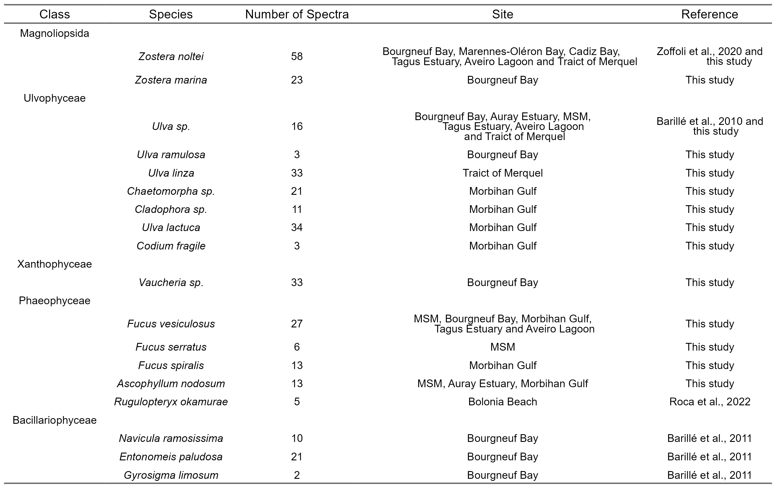
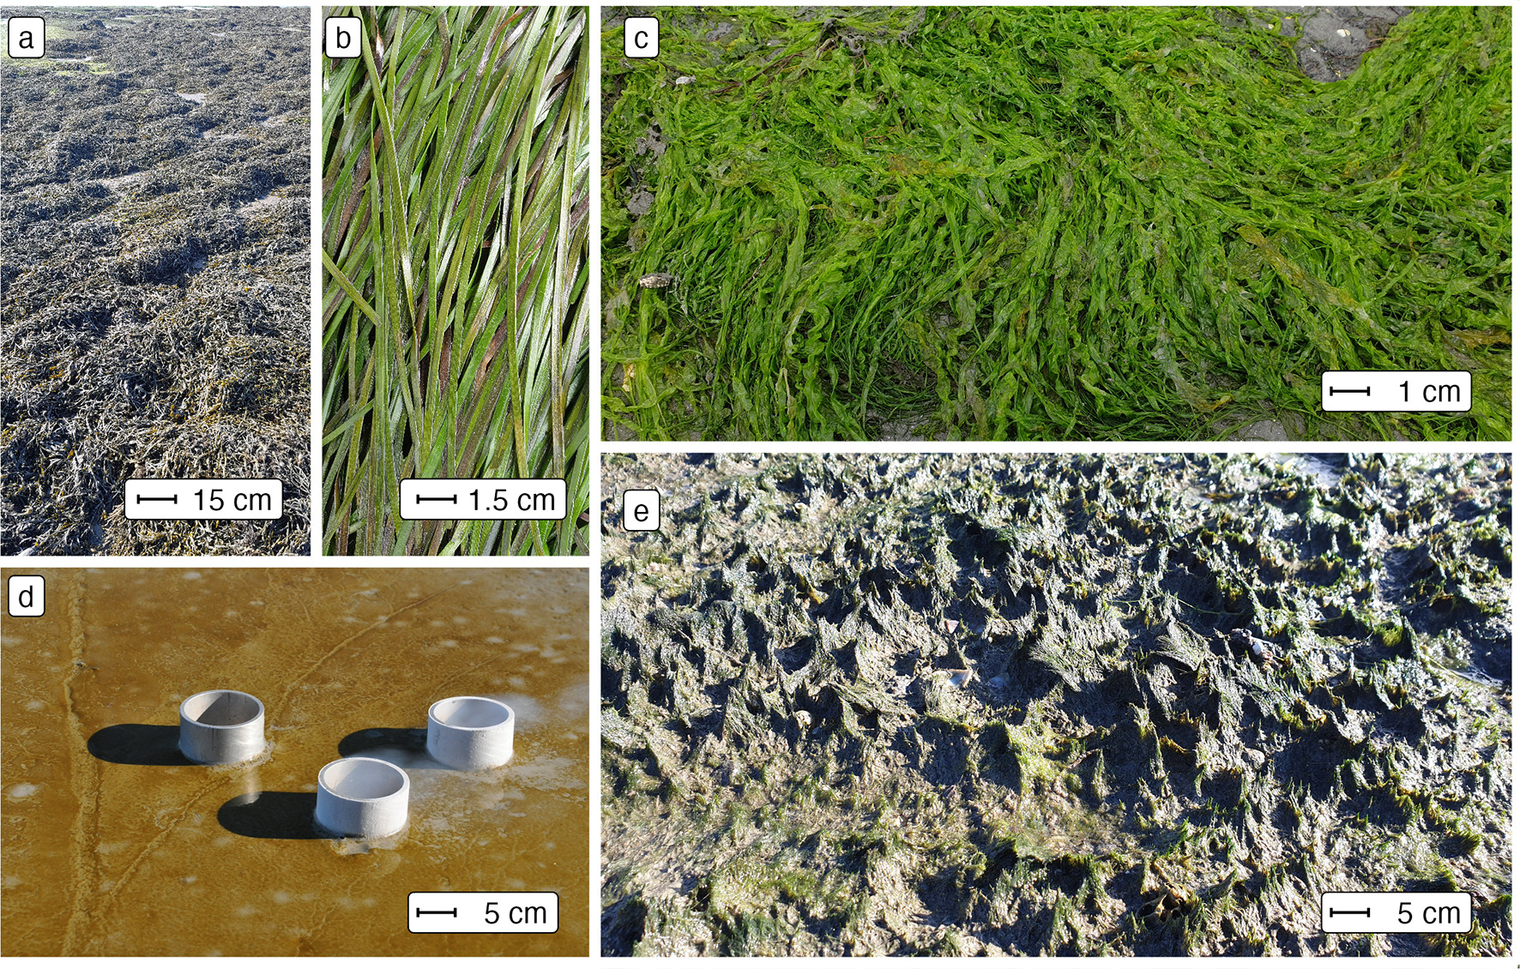
Figure 2.1: Examples of taxonomic classes of soft-bottom intertidal vegetation in the field (a: Phaeophyceae (Fucus vesiculosus), b: Magnoliopsida (Zostera noltei), c: Ulvophyceae (Ulva linza), d: Bacillariophyceae (Diatoms) and e: Xanthophyceae (Vaucheria spp.)). Scale bars show approximate scale.
Multiple field campaigns taking place from 2 hours prior to 2 hours post minimum tide were carried out across temperate intertidal areas along the Western Atlantic coastline during the summer months (Figure 2.2). The campaigns took place in France in Bourgneuf Bay (Barillé et al. 2010, 2011; Zoffoli et al. 2020), Marennes-Oléron Bay, Auray Estuary, Mont-Saint-Michel Bay, Morbihan Gulf and Traict of Merquel, in Spain in Bolonia Beach (Roca et al. 2022) and Bay of Cadiz (Zoffoli et al. 2020), and in Portugal in the Tagus Estuary and Aveiro Lagoon.
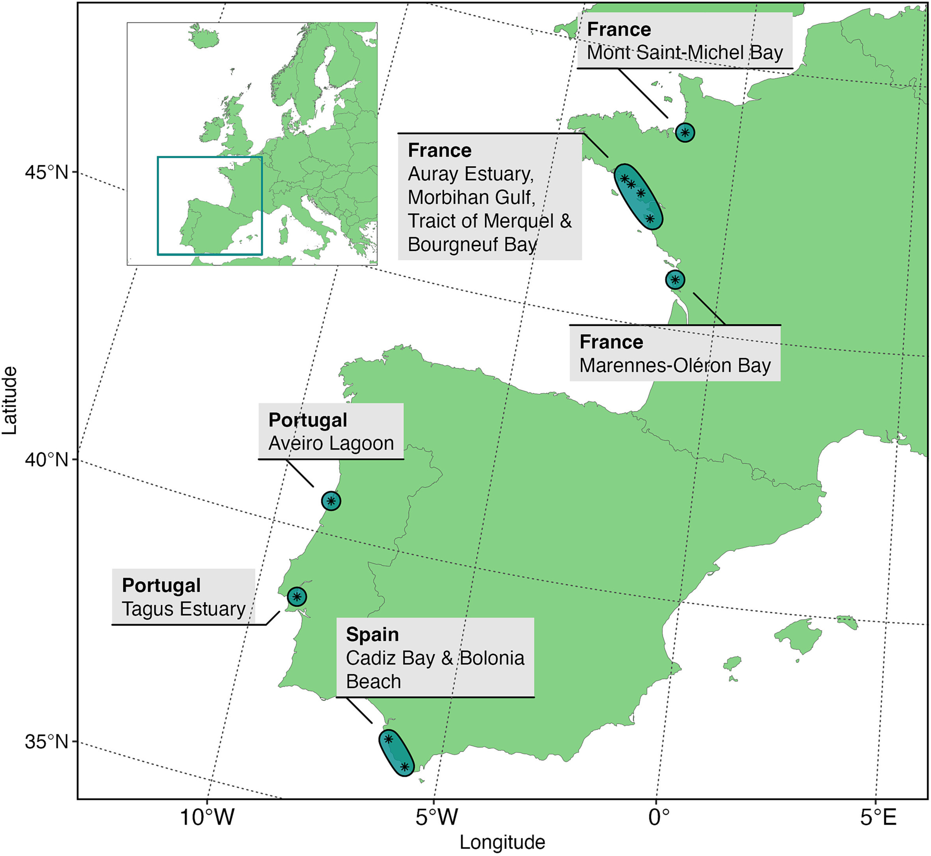
Figure 2.2: Sample collection sites across Europe.

2.2.2 Data Analysis

2.2.2.0.1 Spectral Degradation
The efficacy, efficiency and ability of classifying intertidal soft-bottom vegetation were assessed for a variety of remote-sensing sensors, including two multispectral satellite sensors (the high-resolution imager (HiRI) onboard Pleiades and the multi-spectral instrument (MSI) onboard Sentinel-2), one hyperspectral satellite sensor (the hyperspectral camera (HYC) onboard PRISMA satellite) and one airborne multispectral sensor (MicaSense RedEdge MX-dual Sensor on board a DJI Matrice 200 drone). These sensors cover a gradient of spectral resolution from multispectral to hyperspectral (Figure 2.3). The spectral response functions of Pleiades and Sentinel-2 were used to degrade the hyperspectral library to the respective resolution of each sensors. The highest spatial resolution of Sentinel-2 (10 m) consists of 4 spectral bands while the 20 m sensor has 4 additional bands in the VNIR spectral range (total 8 bands). Sentinel-2 spectral bands, such as at 443 nm, were not used because its spatial resolution (60 m) is too coarse for intertidal seagrass mapping (Zoffoli et al. 2020). To degrade the ASD library to the PRISMA spectral resolution, only central wavelengths and bandwidths (from 400 to 900 nm) were obtained from the Agenzia Spaziale Italiana (ASI 2020). Likewise, central wavelengths with bandwidths were available for the Micasense (“Drone” henceforth). Therefore, the mean of the reflectance values included in the bandwidth of each PRISMA and Drone function band were computed. Across all sensors, a moving average was applied to the ASD spectral library with a 5 nm smoothing window to reduce instrument-induced noise in the data.
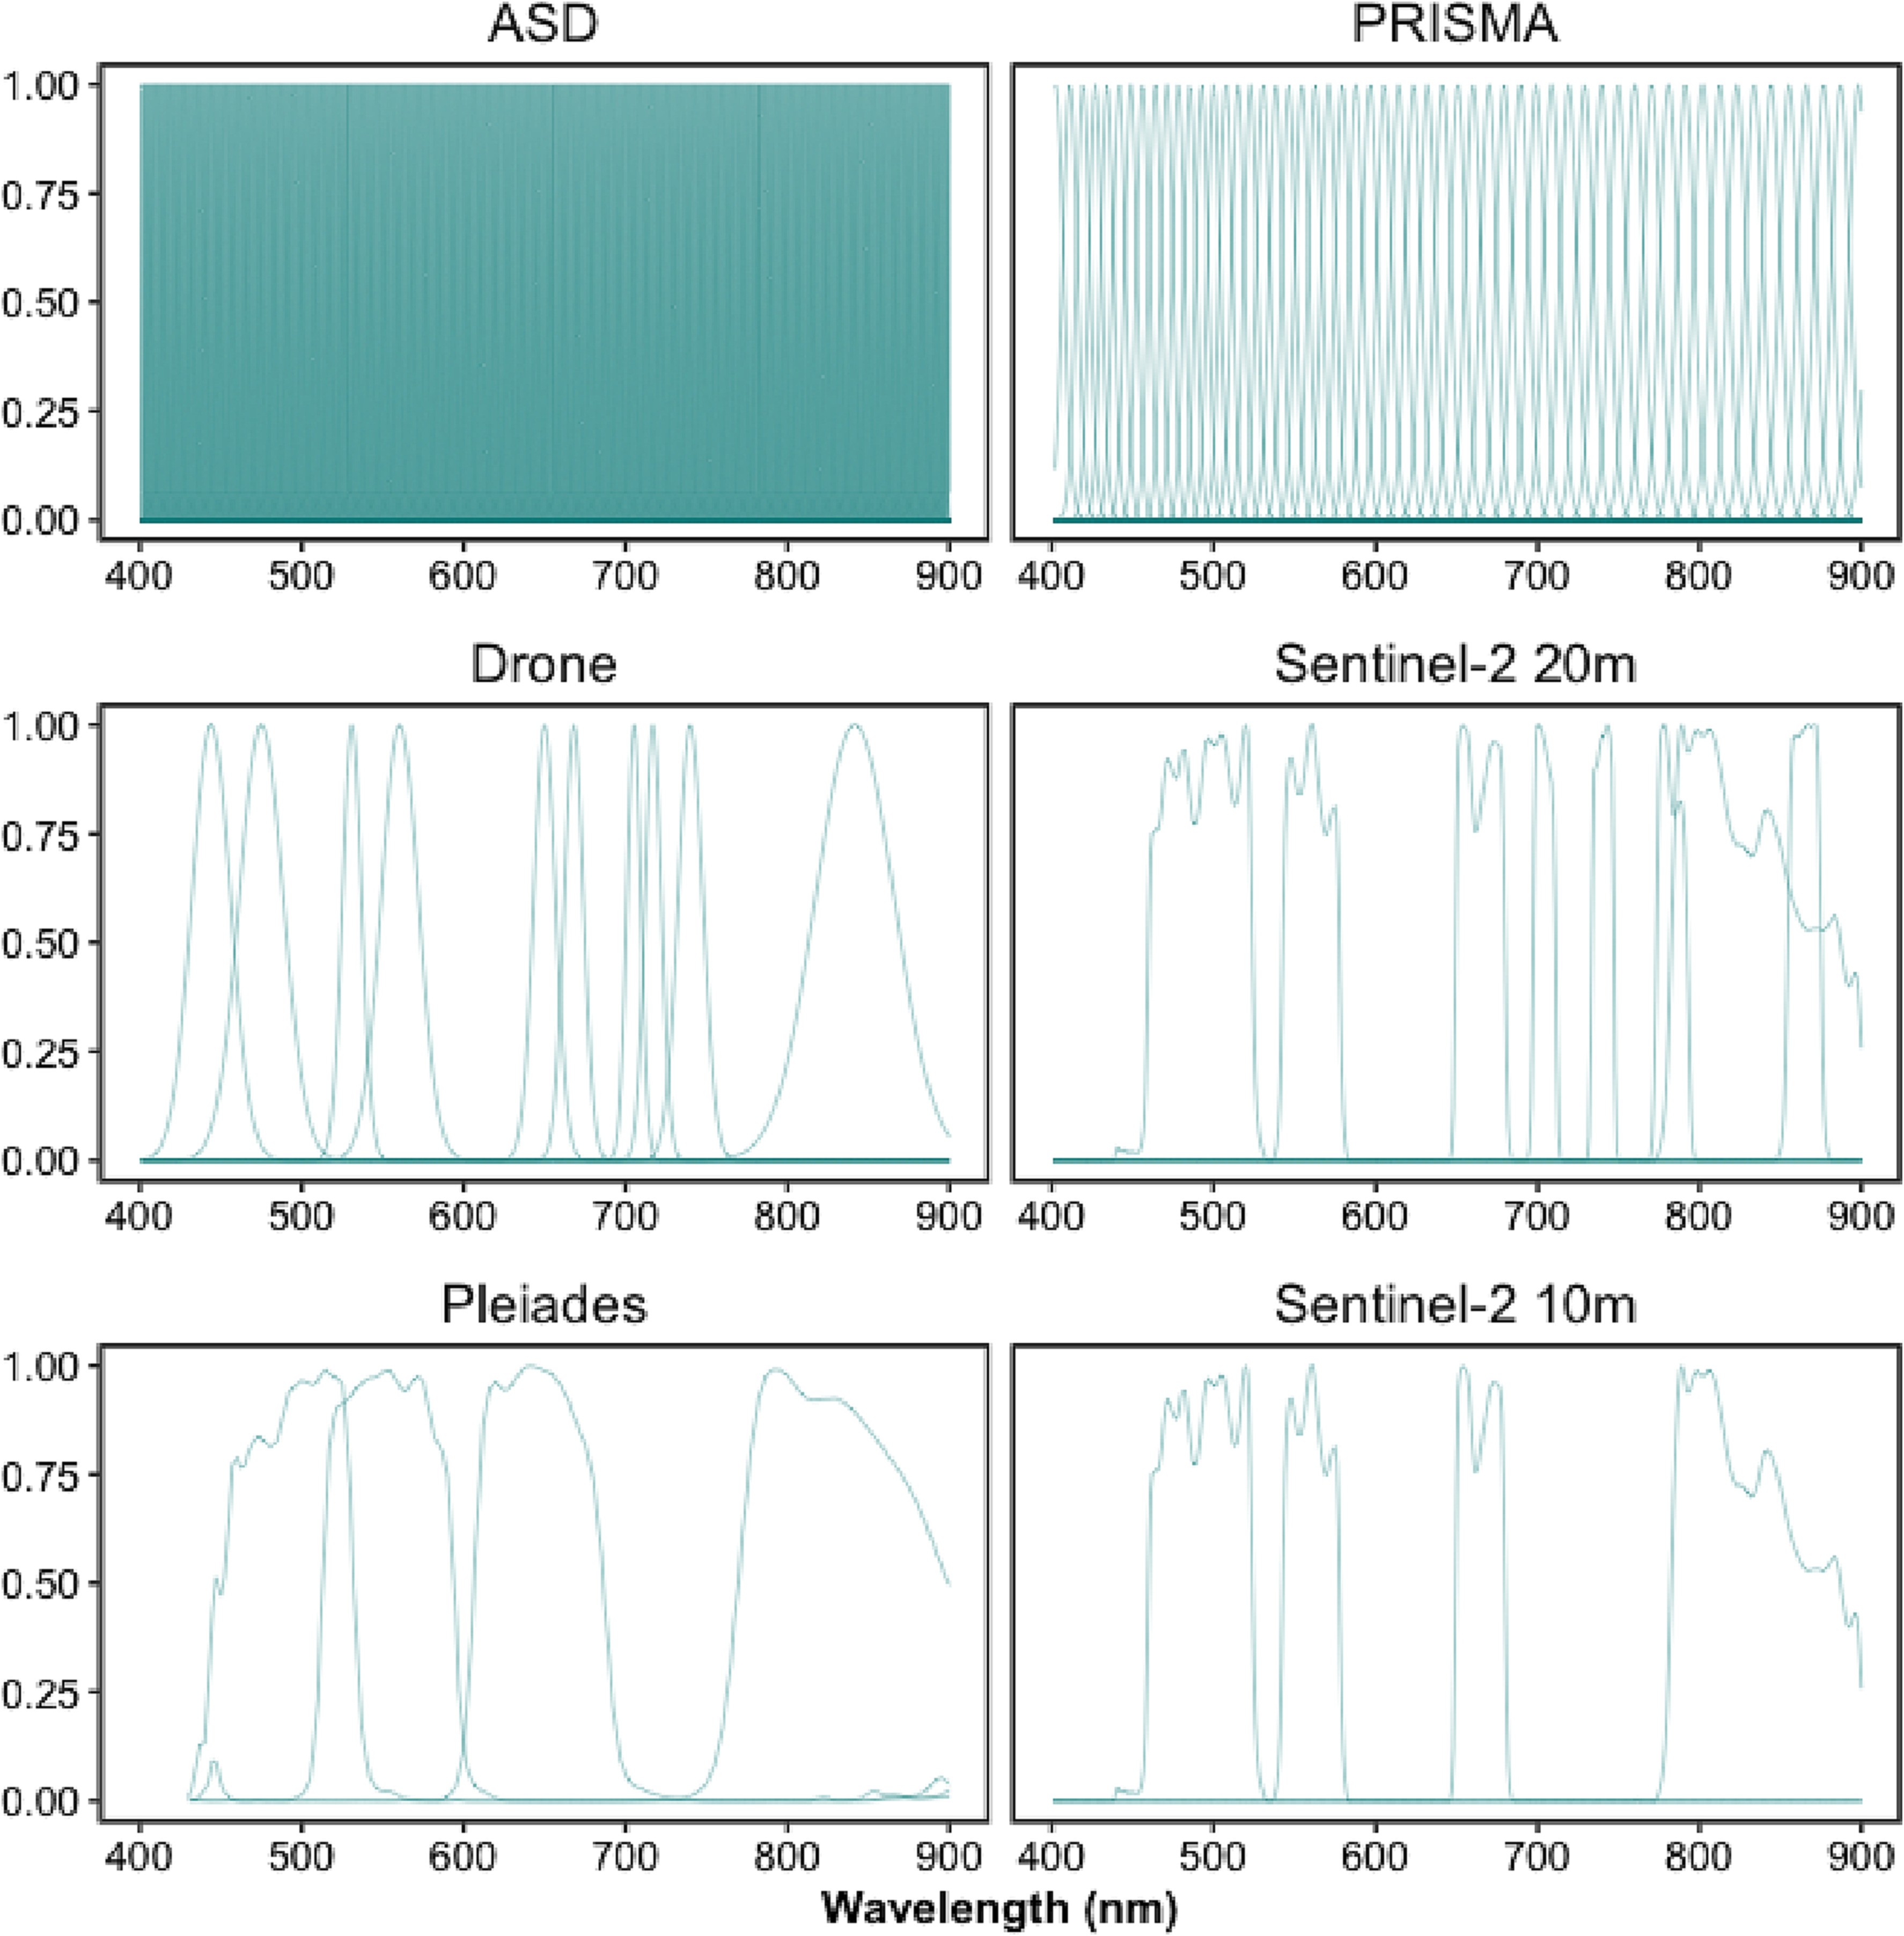
Figure 2.3: Spectral response functions for different hyper- and multi-spectral sensors (ASD, Pleiades, Sentinel-2 (10 m), Sentinel-2 (20 m), Drone, and PRISMA).

2.2.2.0.2 Standardisation
All spectra were standardised to reduce the effect of variable biomass, density or thickness of sample, with a Min-Max transformation (Cao et al. 2017). This calculation emphasised the spectral shapes in the visible range associated with the pigment composition (Douay et al. 2022):
$$R_{i}^{*}\left(λ\right)=\frac{R_{i}\left(λ\right)−min\left(R_{i}\right)}{max\left(R_{i}\right)−min\left(R_{i}\right)}$$
where $R_{i}\left(λ\right)$ is the reflectance at a specific wavelength ($λ$) for a specific spectrum (i), where min($R_{i}$) and max($R_{i}$) are the corresponding minimum and maximum values.

2.2.2.1 Statistical Analysis
To visually assess the differences between classes across different spectral resolutions dissimilarity matrices were computed for all vegetative classes, with the cosine distance to compute a Spectral Angle Mapper (SAM). The SAM algorithm considers that each spectrum is a vector in $n$-dimensions space, $n$ being the number of bands, and measures the angle between two spectra to determine their dissimilarity (Kruse et al. 1993). The difference between classes were visualised and statistically assessed with non-metric Multi-Dimensional Scaling (nMDS) ordination and Analysis of Similarity (ANOSIM) from the ‘vegan’ package within the programming language R (Oksanen et al. 2024). ANOSIM was carried out on the SAM distance matrix using 999 permutations.
To assess the ability of different sensors at classifying intertidal vegetative and non vegetative classes (bare sediments, Bacillariophyceae, Magnoliopsida, Phaeophyceae, Ulvophyceae & Xanthophyceae) from their spectral reflectance data, supervised Machine Learning (ML) algorithms were applied from the “tidymodels” ecosystem of packages within the programming language R (Kuhn and Wickham 2020; R Core Team 2023). Multiple models were developed (Random Forest, XGBoost and Multinomial Classifiers) with relatively similar results. The model described here was an ensemble decision tree classification approach; Random Forest from the “ranger” package (Wright 2024). As Random Forest employs randomisation of trees, 20 repetitions of the analysis were carried out to avoid over or under representation of specific samples. Spectral data were split into training and testing sets using a proportion of 0.75 to 0.25 using the response variable to stratify samples and reduce group imbalance. Training data were then further split into 30 training and validation datasets using bootstrap resamples to allow hyper-parameter tuning from the “rsample” package (Frick et al. 2024). Class was modelled as a function of all available features (standardised reflectance of each wavelength), where all features displaying zero variance across all classes were removed before model tuning as zero variance values would provide no additional information for the models. This meant only the first three bands of Pleiades and Sentinel-2 at 10 m were evaluated as their highest bands in the NIR showed no variance. Models were tuned to maximise the Area Under the Curve of the Receiver Operating Characteristic (ROC), which measures the diagnostic ability of a classifier based on the ratio of false positive and true positive rate. Accuracy, Cohen’s kappa (an accuracy measure that takes into account class size discrepancy), sensitivity and specificity were calculated using the ‘yardstick’ package, while the ‘vip’ package was used to calculated variable importance (Kuhn, Vaughan, and Hvitfeldt 2024; Greenwell and Boehmke 2023). Variable importance will show the relative importance of different wavelengths and was calculated by the prediction error, using permuted out-of-bag data and comparing differences to the prediction error of permuted predictor variables.

2.3 Results

2.3.1 Spectral Signatures at Different Spectral Resolutions
At hyperspectral resolution (ASD, PRISMA), the differences among vegetative habitats were obvious, with the highest dissimilarities observed from 550 – 650 nm and from 700 – 850 nm (Figure 2.4). In particular, the spectral characteristics among the classes were more conspicuous in the green - red spectral range, such as reflectance peaks at 550 nm (Magnoliopsida, Ulvophyceae, Xanthophyceae), 600 nm (Bacillariophyceae), and 650 nm (Xanthophyceae and Bacillariophyceae). The absorption band at 675 nm, present in every class, corresponded to chlorophyll a while at 630 nm a smaller absorption band for the Bacillariophyceae and the Xanthophyceae corresponded to chlorophyll c. Phaeophyceae was the class showing the lowest reflectance in the visible range. All classes but the Ulvophyceae had a positive slope in the NIR. The degradation to a multispectral resolution made these spectral features harder and or impossible to distinguish. The differences between vegetation classes were more pronounced for the drone and Sentinel-2 20 m sensors (8 - 10 spectral bands) than for the Pleiades and Sentinel-2 10 m sensors (4 spectral bands).
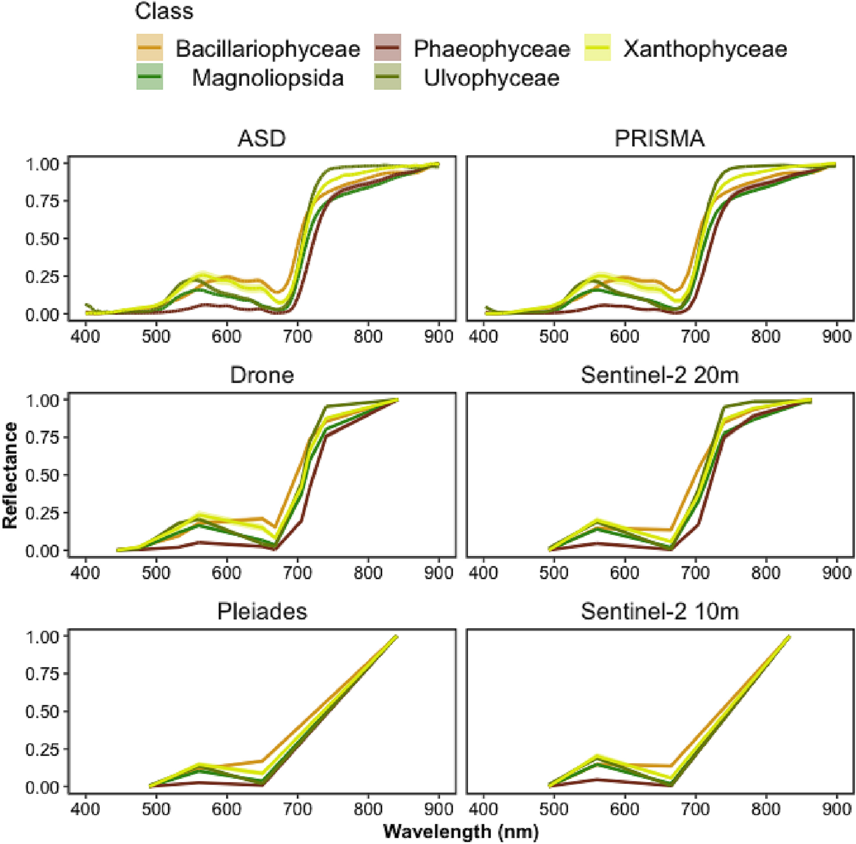
Figure 2.4: Spectral signatures of different vegetation classes at different spectral resolutions (ASD, Pleiades, Sentinel-2 10, Sentinel-2 10-20 m, Drone and PRISMA). Lines show mean signature per wavelength, while shading shows 95% confidence interval. Confidence intervals were consisently small and therefore are hard to distinguish.

2.3.2 Spectral Dissimilarity Between the Taxonomic Classes
The nMDS ordinations calculated with a cosine distance showed that all vegetation classes could be distinguished with a hyperspectral sensor (ASD, PRISMA), despite some overlaps between the Magnioliopsida, Ulvophyceae and Xanthophyceae (Figure 2.5). Interestingly, similar ordination patterns were also observed for the multispectral sensors with the highest number of bands (i.e., Drone, Sentinel-2 20 m). The greatest dissimilarity between classes was observed for the ASD (R = 0.638 & p = 0.001). The differences between PRISMA, the Drone and Sentinel-2 at 20 m were very similar (PRISMA: R = 0.611 & p = 0.001, Drone: R = 0.588 & p = 0.001 & Sentinel-2 at 20 m), while Pleiades and Sentinel-2 at 10 m were far lower (Pleiades: R = 0.49 & p = 0.001 & Sentinel-2 at 10 m). Strong overlaps were observed between the classes Magnioliopsida and Ulvophyceae at the low spectral resolution of Pleiades and Sentinel-2 10 m.
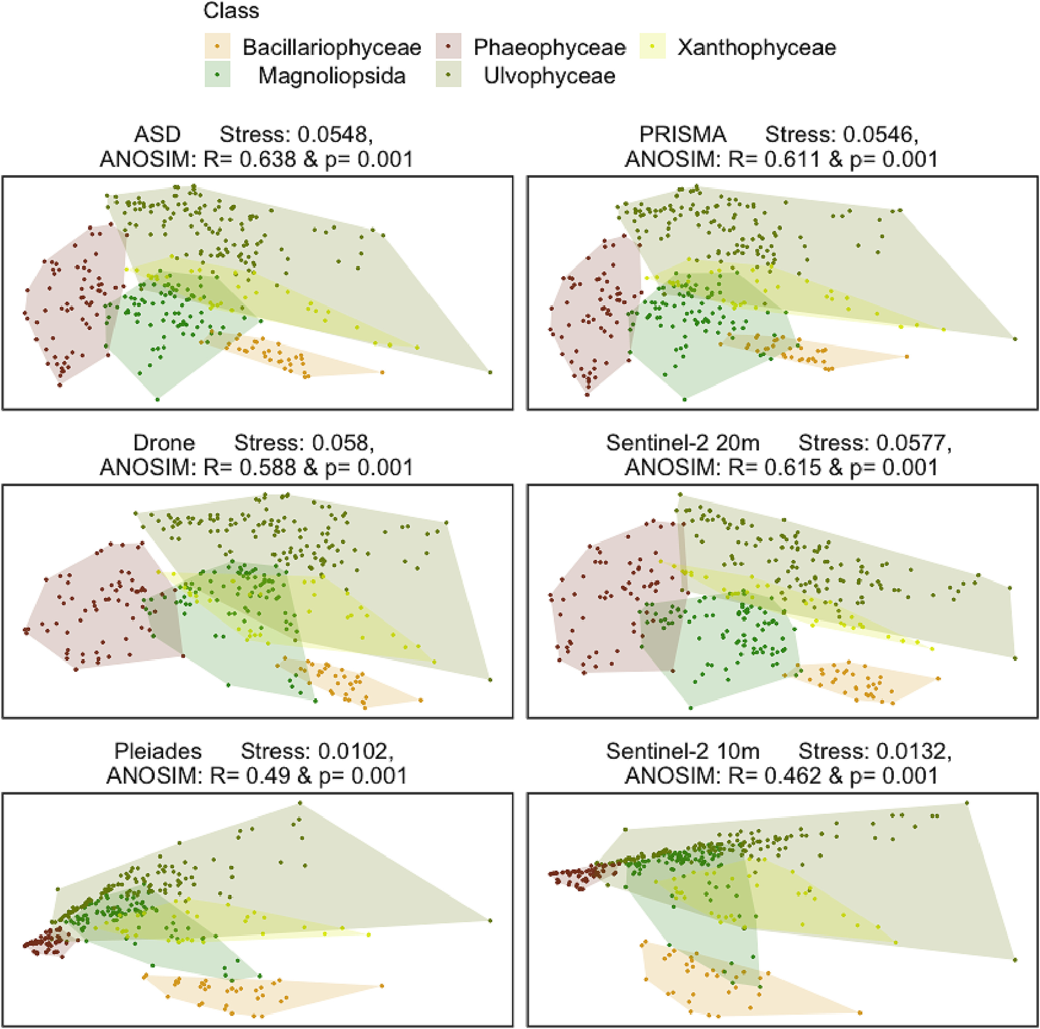
Figure 2.5: nMDS ordination showing similarities between vegetation classes at different spectral resolutions (ASD, Pleiades, Sentinel-2 10, Sentinel-2 10-20 m, Drone and PRISMA). Point distances are based on cosine distance, polygons show the minimum convex hull to surround all points. Stress values show the inaccuracy of the 2 dimensional representations.

2.3.3 Accuracy Across Sensors and Importance of Wavelengths
When assessed by Random Forest modelling, accuracy metrics of different spectral resolutions showed that Sentinel-2 20 m and Drone spectra gave high mean accuracy regardless of accuracy metric (Accuracy: 0.95 ± 0.004 for Sentinel-2 20 m & 0.948 ± 0.004 for Drone. Cohen’s Kappa Accuracy: 0.935 ± 0.006 for Sentinel-2 20 m & 0.934 ± 0.005 for Drone: Figure 2.6 & Table 2.2). Above a spectral resolution of 10 bands, there was no gain in mean accuracy even with large increases in spectral resolution (Accuracy: 0.95 ± 0.005 for ASD & 0.951 ± 0.006 for PRISMA. Cohen’s Kappa Accuracy: 0.936 ± 0.006 for ASD & 0.938 ± 0.008 for PRISMA). The sensors with the lowest spectral resolution (Pleiades and Sentinel-2 10 m) showed the lowest accuracy, yet still were accurate around 80 to 90% of the time (Accuracy: 0.861 ± 0.006 for Pleiades & 0.835 ± 0.008 for Sentinel-2 10 m. Cohen’s Kappa Accuracy: 0.821 ± 0.008 for Pleiades & 0.792 ± 0.005 for Sentinel-2 10 m). Likewise, model specificity and sensitivity showed the greatest values from 8 spectral bands and above, but no increase was shown from 10 to 300 bands (Sensitivity: 0.948 ± 0.006 for Sentinel-2 20 m, 0.941 ± 0.006 for Drone, ± 0.006 for PRISMA & 0.938 ± 0.008 for ASD; Specificity: 0.989 ± 0.001 for Sentinel-2 20 m, 0.989 ± 0.001 for Drone, ± 0.001 for PRISMA & 0.989 ± 0.001 for ASD). Below 8 spectral bands, mean sensitivity and specificity were lowest, yet still around 85% (Sensitivity: 0.847 ± 0.008 for Pleiades & 0.844 ± 0.008 for Sentinel-2 10 m; Specificity: 0.97 ± 0.001 for Pleiades & 0.966 ± 0.002 for Sentinel-2 10 m). Standardised variable importance, the relative amount the inclusion of a variable in the model affected its’ performance, showed the wavelengths the model considered most important (Fig. 7). Consistently across all spectral resolutions, wavelengths 517–556 nm were shown to be highly important. When present, wavelengths around 722–754 nm were the most important. When the variable importance of the ASD was overlaid on the response functions for the different multispectral sensors, the ability of each sensor to effectively sample the wavelengths of interest become clearer (Fig. 8). The Drone and Pleiades sensors effectively sample the top of the peak in importance from 517 to 556 nm, while Sentinel-2 (10 m and 20 m) is only sampling the edges of the peak. Both Pleiades and Sentinel-2 at 10 m did not sample the highest peak of importance from 722 to 754 nm, while the Drone and Sentinel-2 at 20 m only sampled one side of this peak. Generally, the Drone is sampling all the major and minor peaks of importance apart from one minor peak around 780 nm.
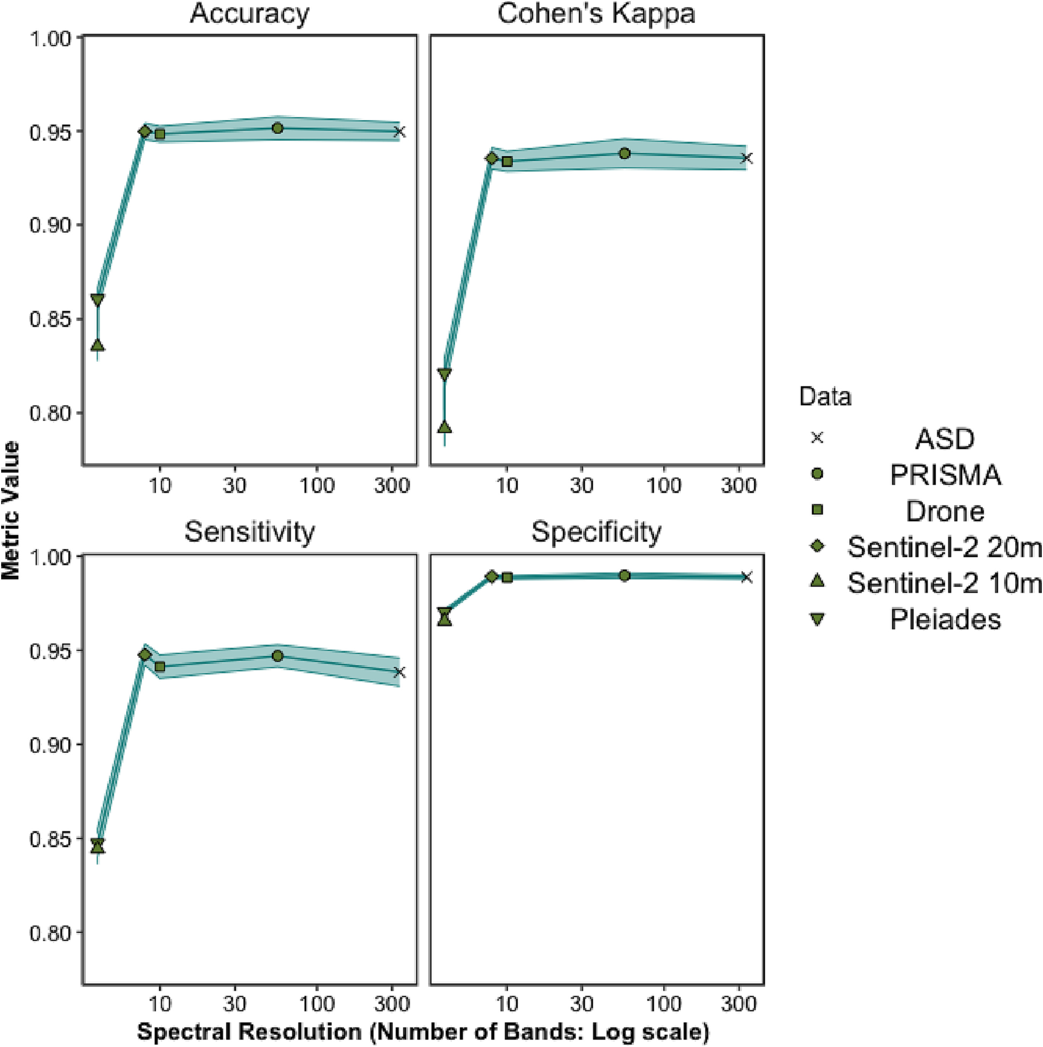
Figure 2.6: Accuracy metrics (accuracy, Cohen’s kappa accuracy, sensitivity and specificity) for different spectral resolutions.
Table 2.2: Accuracy metrics (accuracy, Cohen’s kappa accuracy, sensitivity and specificity) for different spectral resolutions ± standard error.
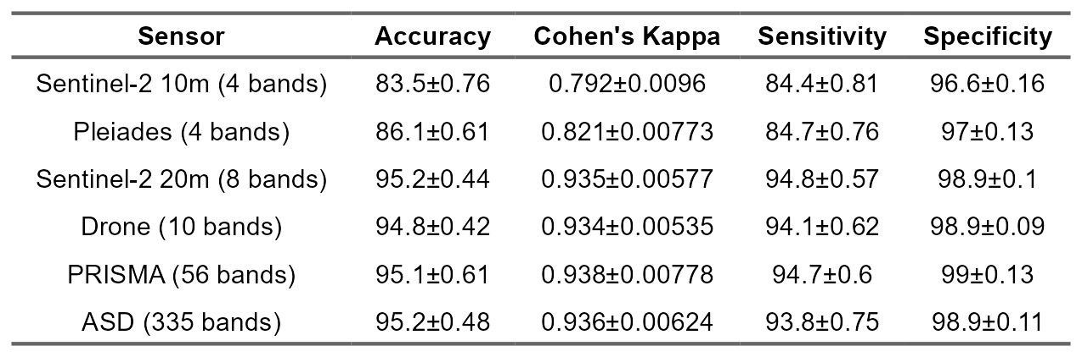
Standardised variable importance, the relative amount the inclusion of a variable in the model affected its’ performance, showed the wavelengths the model considered most important (Figure 2.7). Consistently across all spectral resolutions, wavelengths 517–556 nm were shown to be highly important. When present, wavelengths around 722–754 nm were the most important.
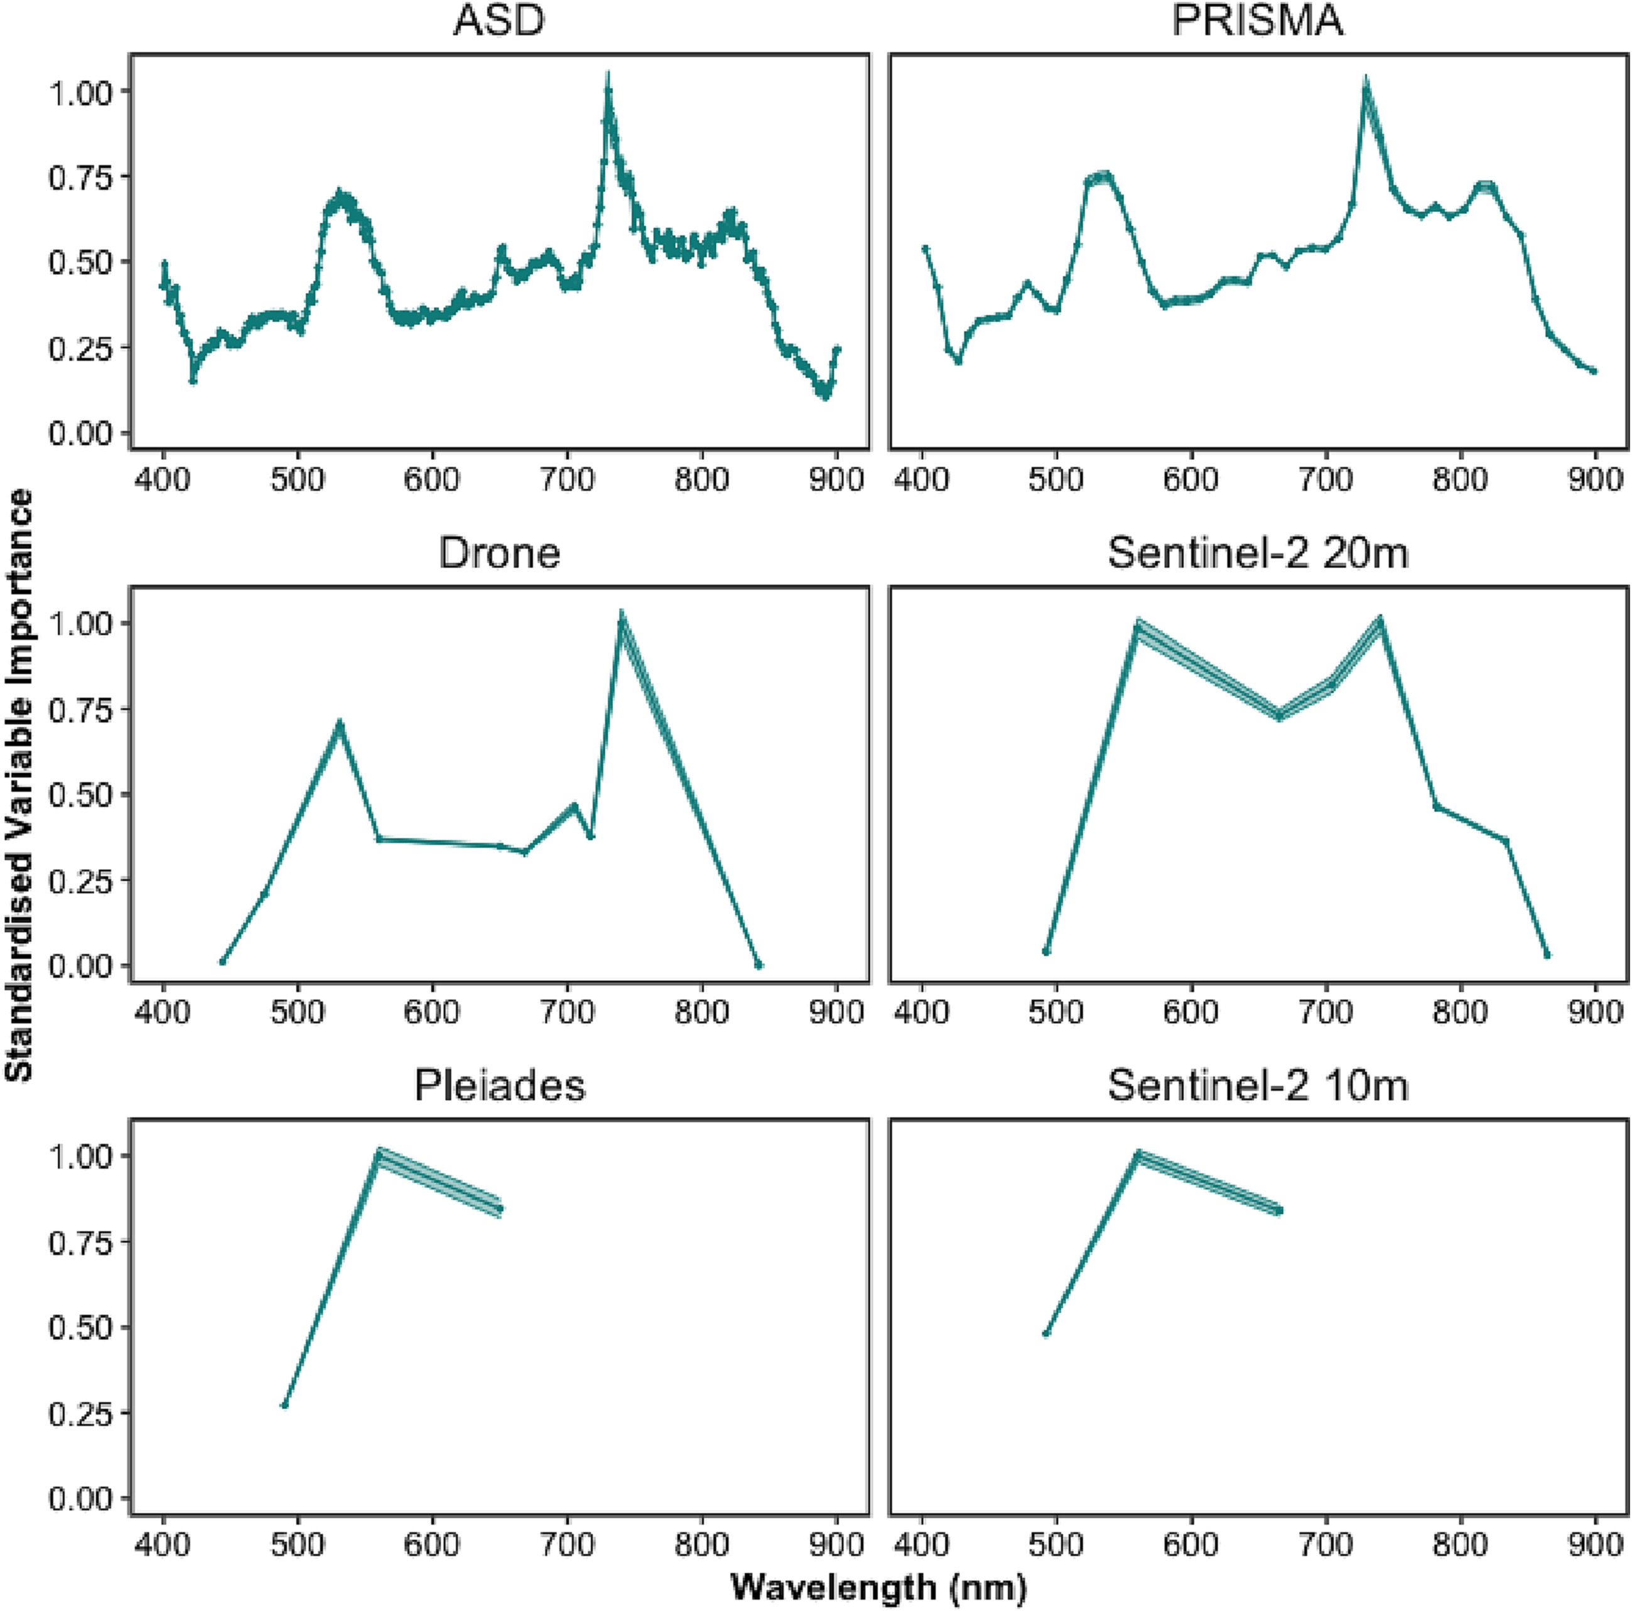
Figure 2.7: The relative importance of different wavelengths for model prediction across spectral resolutions.
When the variable importance of the ASD was overlaid on the response functions for the different multispectral sensors, the ability of each sensor to effectively sample the wavelengths of interest become clearer (Fig. 8). The Drone and Pleiades sensors effectively sample the top of the peak in importance from 517 to 556 nm, while Sentinel-2 (10 m and 20 m) is only sampling the edges of the peak. Both Pleiades and Sentinel-2 at 10 m did not sample the highest peak of importance from 722 to 754 nm, while the Drone and Sentinel-2 at 20 m only sampled one side of this peak. Generally, the Drone is sampling all the major and minor peaks of importance apart from one minor peak around 780 nm.
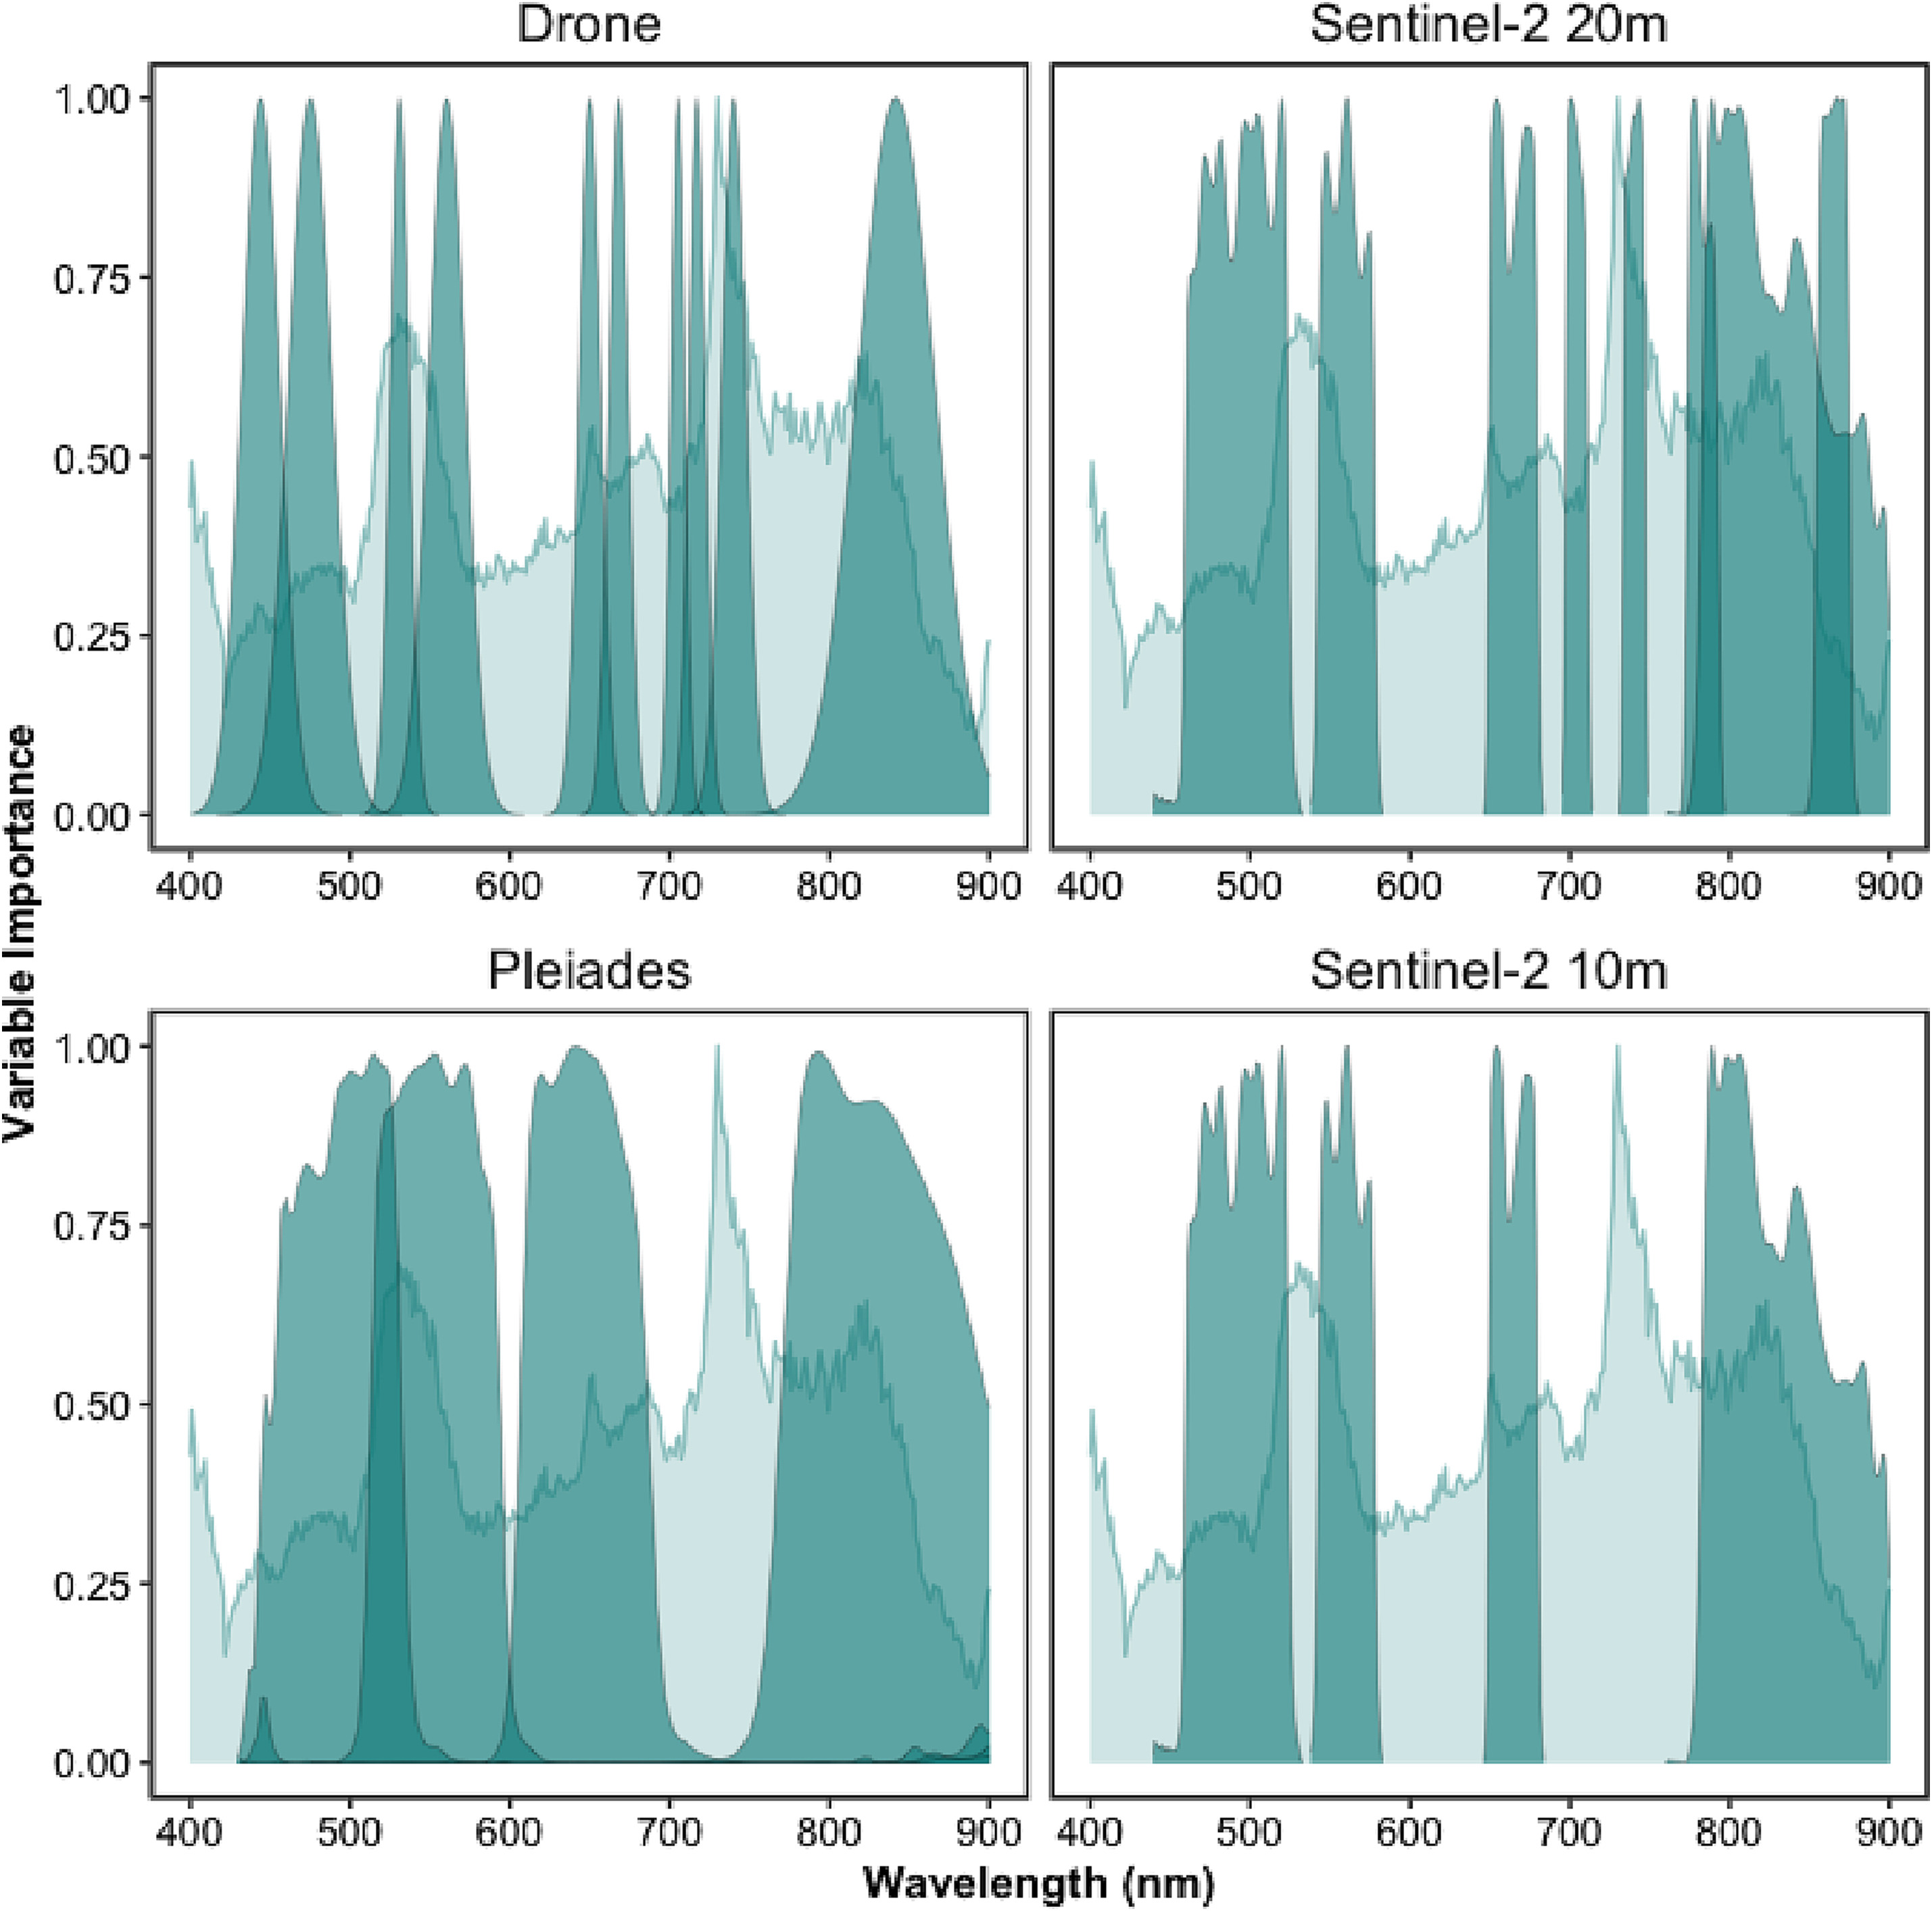
Figure 2.8: The relative importance of different wavelengths for ASD model prediction across the spectral bands of the Drone, Sentinel-2 and Pleiades sensors.

2.3.4 Confusion Matrices
Models accurately classed bare sediments consistently, regardless of spectral resolution (Figure 2.9). Ulvophyceae appeared to be mislabeled the most, while Magnoliopsida and Phaeophyceae showed consistently high prediction accuracy, especially by the Drone data. Across all spectral resolutions a small number of Magnoliopsida samples were mislabeled as Bacilliariophyceae, Xanthophyceae and Ulvophyceae. A few Bacilliariophyceae and Ulvophyceae samples were incorrectly labeled as Magnoliopsida. Likewise, identification of Xanthophyceae was consistenetly poor across all spectral resolutions apart from Sentinel-2 at 20 m (Sensitivity: 0.79 ASD, 0.87 PRISMA, 0.76 Drone, 0.93 Sentinel-2 at 20 m, 0.7 Sentinel-2 at 10 m and 0.5 Pleiades and Specificity: 0.84 ASD, 0.84 PRISMA, 0.86 Drone, 0.82 Sentinel-2 at 20 m, 0.57 Sentinel-2 at 10 m and 0.53 Pleiades). Pleiades and Sentinel-2 at 10 m had the worst Magnoliopsida classification (Sensitivity: 0.66 Sentinel-2 at 10 m and 0.75 Pleiades; Specificity: 0.79 Sentinel-2 at 10 m and 0.8 Pleiades).
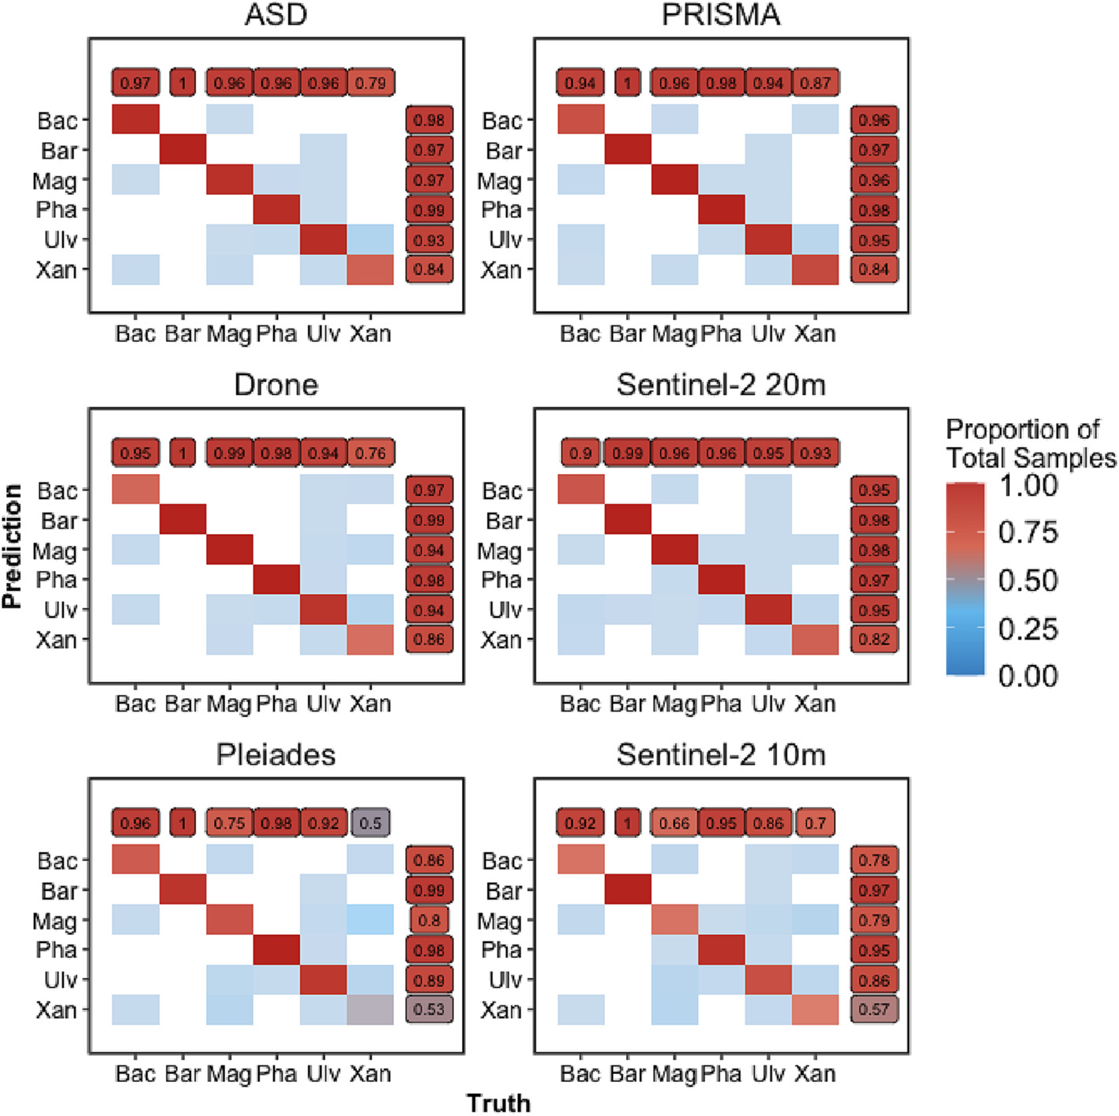
Figure 2.9: Confusion matrices for different spectral resolutions. Colour of tiles show proportion of correct predictions across all 20 repetitions with no colour for 0 predictions. Classes were abreviated Bacillariophyceae as Bac, Bare Sediments as Bar, Magnoliopsida as Mag, Phaeophyceae as Pha and Ulvophyceae as Ulv. Labels with numbers show within class sensitivity and specificity.

2.4 Discussion

2.4.1 Spectral Library and Vegetation Classification
Spectral libraries have been used in coastal areas to analyse the capacity of hyperspectral sensors to discriminate macrophytes at different taxonomic resolutions (Mcilwaine, Casado, and Leinster 2019; Douay et al. 2022; Diruit et al. 2022; for earlier references see Chao Rodríguez et al. 2017) or to estimate the background contribution on benthic diatoms reflectance spectra (Barillé et al. 2011). The spectral library built up for this work was used to study the discriminatory ability of exposed soft-bottom intertidal vegetation at a class taxonomic level for a variety of remote-sensing instruments. Importantly, the classifier was designed to be applicable to both multi- and hyperspectral sensors, which is an advantage compared to classification methods only designed for hyperspectral sensors, such as derivative spectral analysis (Mcilwaine, Casado, and Leinster 2019). The discrimination accuracy of the vegetation classes increased with spectral resolution, yet showed diminishing returns for resolutions above ~10 spectral bands. The main result of this study was the capacity to discriminate seagrass from green macroalgae at a multipectral resolution with ten bands when using machine learning classification techniques. As expected, this discrimination was also possible with hyperspectral sensors. Sensors with a spectral resolution of four bands, such as Pleiades and Sentinel 2 (10 m), were poorer at accurately discriminating between green macroalgae and seagrass, as their spectral shapes were too similar (Figure 2.4 & Figure 2.6). The importance of effective seagrass classification is considerable, with seagrass conservation and restoration contributing to 16 of the 17 United Nations Sustainable Development Goals (SDGs: R. K. Unsworth et al. 2022). A practical restraint of this analysis is the necessity for non-submerged samples. However, the main challenge in mapping seagrass through remote sensing stems from confusion between similarly pigmented green algae, leading to high levels of uncertainty in current seagrass extent (McKenzie et al. 2020). Vegetation classes were consistently distinguishable from bare sediments, as found elsewhere between bare rock and algae (Douay et al. 2022). Likewise, random forest models were successfully able to discriminate between habitats (See also: Oiry and Barillé 2021; Légaré et al. 2022), with generally lower accuracy at lower spectral resolution, yet even at the lowest spectral resolutions (Pleiades and Sentinel-2 10 m) there was a mean test accuracy of 86.1% and 83.5% respectively (82.1% and 79.2% respectively when class imbalance was considered with Cohen’s kappa).

2.4.2 Spectral Discrimination and Pigment Composition
Two wavelength regions, respectively in the green (~517–556 nm) and NIR (~722–754 nm) spectral domains, were identified for their importance to the random forest model as contributing most to the discrimination between taxonomic classes (Figure 2.7). The wavelength window around 530 nm has already been recommended to distinguish different species of seagrass (Fyfe 2003), and brown from green macroalgae (Mcilwaine, Casado, and Leinster 2019). The spectral differences in the visible range between the classes are partially explained by their difference of pigment composition (Table 2.3). Pigments have different optical properties and absorption wavelengths, which influence the reflectance spectra shapes. Chlorophyll c and fucoxanthin absorb light at 636 nm and 550 nm respectively (Méléder et al. 2013). Those pigments are present amongst diatoms and brown macroalgae, but absent in green macrophytes. Xanthophyceae also contain chlorophyll c, but no fucoxanthin (Table 2.3). Chlorophylls and carotenoids absorptions can thus be used as diagnostic features to identify vegetation types that do not share the same pigmentary composition (Casal et al. 2012; Douay et al. 2022; Méléder et al. 2013). In this work, spectral differences have been observed between two classes having a similar pigment composition, the Magnoliopsida and the Ulvophyceae (Table 2.3). This indicates that the pigment concentrations and relative proportions, which can vary inside the main vegetation groups (A. Bargain et al. 2013; Beach et al. 1997), contribute to the spectral discrimination between taxonomic classes sharing the same pigment composition. Variations in the configuration of photosynthetic and accessory pigments in the 3D pigment-protein complexes within cells can also change the absorption features of taxons sharing the same pigments (Kirk 1994), while 3D disposition of the plants as a whole can alter the magnitude of reflectance (Hedley et al. 2018). As pigment absorptions correspond to narrow spectral bands (Méléder et al. 2013; Douay et al. 2022), discriminating the different types of intertidal vegetation relies on access to these specific absorption wavelengths, which explains why the hyperspectral sensors are generally more accurate than the multispectral sensors. For the latter, the lack of relevant spectral bands and the large width of the available ones does not permit to capture the diagnostic absorption features. NIR wavelengths have long been recognized as relevant for the spectral discrimination of terrestrial plant diversity (Schmidt and Skidmore 2003). At these wavelengths, spectral signatures are mainly a function of light scattering determined by the internal structure of leaves for angiosperms or thallus for macroalgae (Guyot 1990). Fyfe (2003) showed that seagrass species could be separated using NIR wavelengths, with a significant change in the slopes between 700 and 900 nm. In our study, the min-max standardization preserved the slope changes for this spectral domain while removing the difference related to biomass variations (Annaëlle Bargain et al. 2012). Within the NIR, the ~722-754 nm wavelength range was identified in our work as the most discriminant for the spectral separation of the taxonomic classes of intertidal macrophytes. The better results obtained with the Drone and Sentinel-2 (20 m) bands suggest that a multispectral sensor with 10 relevant VNIR spectral bands could discriminate the main classes considered in this study. Furthermore, the wavelengths of importance for distinguishing the taxonomic classes here showed that the sensor used by Sentinel-2 could be greatly improved by the inclusion of a band at the main peaks of importance (∼517–556 nm and ∼ 722–754 nm). Both Pleiades and Sentinel-2 at 10 m miss the the peak of highest importance. Furthermore, the marginally higher performance of the Pleiades sensor compared to that of the Sentinel-2 at 10 m could be linked to the overlap of two Pleiades bands over the ∼517–556 nm peak, while Sentinel-2 at 10 m only has bands either side of this peak. Thus, future satellite missions aiming to provide information on global habitat cover, especially including intertidal habitats, should aim to provide sensors with spectral patterns that cover the important wavelengths shown here. Dekker et al. (2018) highlighted the utility multispectral sensors could have for monitoring a wide range of aquatic systems, recommending ~26 bands between 380 and 780 nm, specifically 684 nm to capture chlorophyl-a fluorescence. From the current analysis focusing on intertidal habitats, the most important wavelengths to cover would be around 530 & 730 nm. The main reason for this difference with the recommendations of Dekker et al. (2018) is that their work was specifically focused on submerged vegetation and addressed a broader range of objectives. For an effective monitoring system, specific and broad objectives of the satellite will ideally dictate the spectral coverage of the sensors used.
Table 2.3: Photosynthetic and carotenoid pigments present (1) or absent (0) in each taxonomic class, along with their absorption wavelength measured in vivo and in vitro with an ASD spectroradiometer and by High Performance Liquid Chromatography (HPLC) respectively. Chl b: chlorophyll b, Chl c: chlorophyll c, Fuco: fucoxanthin, Zea: zeaxanthin, Diato: diatoxanthin, Diadino: diadinoxanthin, Neo: neoxanthin.
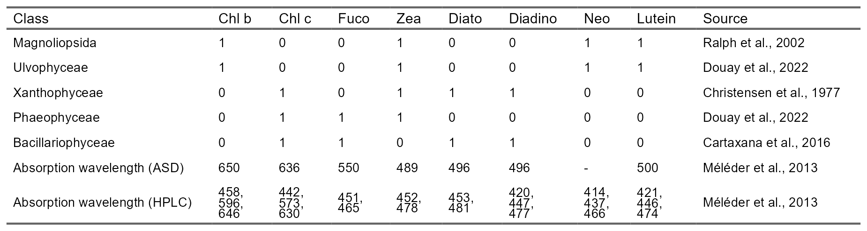

2.4.3 Geographical and Temporal Range of Applicability
The present spectral library aimed to represent a diversity of soft-bottom intertidal vegetation, with the main objective of discriminating seagrass from green macroalgae. However, it has a greater diversity of green macrophytes, making unbalanced among classes. Green macroalgae represent around 33% % of the library with 121 spectra out of 366, while the yellow macroalgae only have 33 spectra. Such a difference has an impact on the statistical analysis and the discrimination results, as some species are over-represented and others underrepresented. Yet, use of Cohen’s kappa, which is an accuracy metric taking into consideration this imbalance, gave minimal difference to global accuracy. This library was built with data collected on the Atlantic coasts of France, Spain and Portugal and could be improved by the addition of new species or spectra from the existing species from other sites, both across Europe and globally.
As advised by Bajjouk et al. (2019), Z. noltei spectral data were collected at their development peak (June to September), as it is known that these macrophytes have a seasonal pigment variation (A. Bargain et al. 2013). Likewise, Légaré et al. (2022) found that depending on the season, spectral reflectance from intertidal habitats can vary significantly. As such, the current spectral library should not be used outside a late spring and summer period for Western Europe, as the varying pigment content can affect the reflectance spectral shapes. Seagrass spectral analysis could also be refined by taking into account the presence of epiphytes on their leaves, which was not done in this study. Epiphytes on seagrass leaves are known to have an impact on the shape of the reflectance spectra (Fyfe 2003), as they are composed of diatoms and brown algae. This might explain the proximity between some seagrass and brown macroalgae spectra and the overlap between the diatoms and the seagrass (Figure 2.5). The presence of epiphytes could alter the relevance of the most discriminative wavelengths between seagrass and other macroalgae. Furthermore, this library was created using 100% cover of taxonomic classes. This homogeneity is often rare at the satellite pixel scales (10 - 60 m), meaning future work should assess the spectral signatures of mixed intertidal vegetation to best predict extent of heterogeneous intertidal vegetation.

2.4.4 Implications for Coastal Biodiversity Studies
The importance of long term monitoring of ecosystems is becoming more acknowledged, especially when monitoring human impacts that may affect Essential Biodiversity Variables (EBVs), such as important habitats, species, or the functioning of those species or habitats (Lengyel et al. 2008; Perera-Valderrama et al. 2020; Livore et al. 2021; B. F. Davies et al. 2021, 2022; El-Hacen et al. 2020). This is becoming even more apparent with the acceleration of human induced climate change, which is likely to exacerbate or accelerate the effects of many other human impacts (Cramer et al. 2018; Sage 2020). Yet, in situ long term monitoring of EBVs is rare (Edwards et al. 2010). This rarity is due to a range of factors, most of which are driven by financial cost, especially if multiple fieldwork campaigns per year are required to capture seasonal variation (Condal et al. 2012). Furthermore, many human impacts can rarely be predicted a priori, so the ability to monitor their impact with sufficient previous data is circumstantial (Sheehan et al. 2021; B. F. R. Davies et al. 2022). This prior data is imperative to properly monitor human impacts and subsequently manage the activities leading to those impacts appropriately (Underwood 1992; Fox et al. 2017; Edgar et al. 2004). The extent, both temporally and spatially, of Earth Observation (EO) from satellite data alongside its accessibility means it has been used to study long term anthropogenic impacts (Hu, Hu, and Ming-Xia 2017; Santos et al. 2020; Lizcano-Sandoval et al. 2022; Zoffoli et al. 2021). Unlike in situ monitoring data, past EO data are easily available, meaning that the long term manifestation of novel phenomena can be assessed effectively (Mahrad et al. 2020). Here, it was shown that spectral reflectance measurements from a relatively low spectral resolution sensor (8-10 bands: e.g. sensor of Sentinel-2 at 20 m resolution) could effectively and accurately classify soft-bottom intertidal vegetative habitats. However, the importance of spectral coverage has also been highlighted; when EO is being utilised, the specific response functions of sensors need to be aligned effectively with the objectives of the analysis. These considerations, alongside the temporal and spatial scales; revisit times of satellites, and the ability for satellites sensors to effectively observe important spectral differences after atmospheric correction is applied, will dictate the most appropriate satellites to be included in a Global Ocean Observing System (GOOS) for optimal monitoring and understanding of the Essential Ocean Variables (EOVs) in coastal ecosystems studies.

2.4.5 Conclusions
Here, the ability to distinguish between five different vegetative intertidal habitats was assessed by analysing their spectral reflectance signatures. Around 366 spectra were compiled across the European Atlantic coast, from Southern Spain to Northern France. The spectral library was analysed at different multi- and hyperspectral resolutions with the emphasis on comparing commonly used satellite and drone sensors. This analysis not only highlighted the ability of a random forest spectral classification model to distinguish between differently pigmented habitats but also between similarly pigmented classes (green algae and seagrass). This approach could aid with ongoing efforts to accurately estimate global seagrass extent, alongside common methods such as Normalised Difference Vegetation Index (NDVI) that can provide proxies for vegetation coverage, such as monospecific intertidal seagrass meadow (Zoffoli et al. 2020). In particular, our work demonstrated the potential of discriminating intertidal seagrass from Ulvophyceae using satellite remote sensing, therefore unlocking a strong limitation for seagrass mapping in heterogeneous environments. High accuracy at distinguishing habitats was found for hyperspectral sensors as well as multispectral sensors consisting of >8 bands in the visible and near-infrared (ASD, PRISMA, Sentinel-2 at 20 m resolution and the MicaSense RedEdge MX-dual Drone sensor). As climate change alongside other anthropogenic activities continue to impact community stability and functions, and potentially altering ecosystem services, monitoring of habitats becomes ever more important. Intertidal habitats are a vital link between terrestrial and coastal marine ecosystems, yet due to their dynamic nature and inaccessibility are difficult to assess. Therefore, the ability to monitor these ecosystems over time with high spatial and temporal resolution is important. This research provides the evidence that soft-bottom intertidal green macrophytes can be accurately classified at spectral resolutions currently available from satellite missions, assuming consistency after atmospheric correction, thus offering new perspectives for EO biodiversity studies of intertidal ecosystems. It further provides advice for the next generation of satellite missions in terms of optimal spectral resolution and important wavelengths.

3. Summary
In summary, this book has no content whatsoever.
1 + 1
[1] 2

References
ASI. 2020. “PRISMA Products Specification Document Issue 2.3 Date 12/03/2020.” Agenzia Spaziale Italiana. http://prisma.asi.it/missionselect/docs/PRISMA%20Product%20Specifications_Is2_3.pdf.
Bajjouk, Touria, Ichrak Zarati, Lucas Drumetz, and Mauro Dalla Mura. 2019. “Spatial Characterization of Marine Vegetation Using Semisupervised Hyperspectral Unmixing.” 2019 10th Workshop on Hyperspectral Imaging and Signal Processing: Evolution in Remote Sensing (WHISPERS), 1–5.
Bargain, Annaëlle, Marc Robin, E Le Men, A Huete, and Laurent Barillé. 2012. “Spectral Response of the Seagrass Zostera Noltii with Different Sediment Backgrounds.” Aquatic Botany 98 (1): 45–56.
Bargain, A., M. Robin, V. Méléder, P. Rosa, E. Le Menn, N. Harin, and L. Barillé. 2013. “Seasonal spectral variation of Zostera noltii and its influence on pigment-based Vegetation Indices.” Journal of Experimental Marine Biology and Ecology 446: 86–94. https://doi.org/10.1016/j.jembe.2013.04.012.
Barillé, Laurent, Jean Luc Mouget, Vona Méléder, Philippe Rosa, and Bruno Jesus. 2011. “Spectral response of benthic diatoms with different sediment backgrounds.” Remote Sensing of Environment 115 (4): 1034–42. https://doi.org/10.1016/j.rse.2010.12.008.
Barillé, Laurent, Marc Robin, Nicolas Harin, Annaëlle Bargain, and Patrick Launeau. 2010. “Increase in seagrass distribution at Bourgneuf Bay (France) detected by spatial remote sensing.” Aquatic Botany 92 (3): 185–94. https://doi.org/10.1016/j.aquabot.2009.11.006.
Beach, K. S., H. B. Borgeas, N. J. Nishimura, and C. M. Smith. 1997. “In vivo absorbance spectra and the ecophysiology of reef macroalgae.” Coral Reefs 16 (1): 21–28. https://doi.org/10.1007/s003380050055.
Beltrand, Maeva, Ariel Dineen, Claudia Hitzeroth, Bianca Baum, Carla de Cerff, Casha de Vos, Jemma Lewis, Sandra Zaroufis, and Deena Pillay. 2022. “Warming Effects on Two Autogenic Engineers (Zostera capensis and Gracilaria gracilis): Consequences for Macrofaunal Assemblages and Benthic Heterogeneity in Intertidal Sandflat Ecosystems.” Estuaries and Coasts 45 (1): 247–59. https://doi.org/10.1007/s12237-021-00949-8.
Brondízio, E. S., J. Settele, S. Díaz, and H. T. (eds) Ngo. 2019. IPBES (2019), Global assessment report of the Intergovernmental Science-Policy Platform on Biodiversity and Ecosystem Services. https://ipbes.net/global-assessment%0Ahttps://ipbes.net/global-assessment-report-biodiversity-ecosystem-services.
Bryndum-Buchholz, Andrea, Derek P Tittensor, Julia L Blanchard, William WL Cheung, Marta Coll, Eric D Galbraith, Simon Jennings, Olivier Maury, and Heike K Lotze. 2019. “Twenty-First-Century Climate Change Impacts on Marine Animal Biomass and Ecosystem Structure Across Ocean Basins.” Global Change Biology 25 (2): 459–72.
Cao, Faxian, Zhijing Yang, Jinchang Ren, Mengying Jiang, and Wing-Kuen Ling. 2017. “Does Normalization Methods Play a Role for Hyperspectral Image Classification?” no. 2: 2–7. http://arxiv.org/abs/1710.02939.
Cardoso, PG, MA Pardal, AI Lillebø, SM Ferreira, D Raffaelli, and JC Marques. 2004. “Dynamic Changes in Seagrass Assemblages Under Eutrophication and Implications for Recovery.” Journal of Experimental Marine Biology and Ecology 302 (2): 233–48.
Casal, G., T. Kutser, J. A. Domínguez-Gómez, N. Sánchez-Carnero, and J. Freire. 2013. “Assessment of the hyperspectral sensor CASI-2 for macroalgal discrimination on the Ría de Vigo coast (NW Spain) using field spectroscopy and modelled spectral libraries.” Continental Shelf Research 55: 129–40. https://doi.org/10.1016/j.csr.2013.01.010.
Casal, G., N. Sánchez-Carnero, J. A. Domínguez-Gómez, T. Kutser, and J. Freire. 2012. “Assessment of AHS (Airborne Hyperspectral Scanner) sensor to map macroalgal communities on the Ría de vigo and Ría de Aldán coast (NW Spain).” Marine Biology 159 (9): 1997–2013. https://doi.org/10.1007/s00227-012-1987-5.
Chao Rodríguez, Y., J. A. Domínguez Gómez, N. Sánchez-Carnero, and D. Rodríguez-Pérez. 2017. “A comparison of spectral macroalgae taxa separability methods using an extensive spectral library.” Algal Research 26 (May): 463–73. https://doi.org/10.1016/j.algal.2017.04.021.
Condal, Fernando, Jacopo Aguzzi, Francesc Sarda, Marc Nogueras, Javier Cadena, Corrado Costa, J Del Rı́o, and Antoni Manuel. 2012. “Seasonal Rhythm in a Mediterranean Coastal Fish Community as Monitored by a Cabled Observatory.” Marine Biology 159 (12): 2809–17.
Cramer, Wolfgang, Joël Guiot, Marianela Fader, Joaquim Garrabou, Jean-Pierre Gattuso, Ana Iglesias, Manfred A Lange, et al. 2018. “Climate Change and Interconnected Risks to Sustainable Development in the Mediterranean.” Nature Climate Change 8 (11): 972–80.
Davies, Bede Ffinian Rowe, Luke Holmes, Martin J Attrill, and Emma V Sheehan. 2022. “Ecosystem Benefits of Adopting a Whole-Site Approach to MPA Management.” Fisheries Management and Ecology.
Davies, Bede FR, Luke Holmes, Anthony Bicknell, Martin J Attrill, and Emma V Sheehan. 2022. “A Decade Implementing Ecosystem Approach to Fisheries Management Improves Diversity of Taxa and Traits Within a Marine Protected Area in the UK.” Diversity and Distributions 28 (1): 173–88.
Davies, Bede FR, Luke Holmes, Adam Rees, Martin J Attrill, Amy Y Cartwright, and Emma V Sheehan. 2021. “Ecosystem Approach to Fisheries Management Works—How Switching from Mobile to Static Fishing Gear Improves Populations of Fished and Non-Fished Species Inside a Marine-Protected Area.” Journal of Applied Ecology 58 (11): 2463–78.
Dekker, Arnold G, Nicole Pinnel, Peter Gege, Xavier Briottet, Steef Peters, Kevin R Turpie, Sindy Sterckx, et al. 2018. “Feasibility Study for an Aquatic Ecosystem Earth Observing System Version 1.2.” CEOS.
Dierssen, H. M., A. Chlus, and B. Russell. 2015. “Hyperspectral discrimination of floating mats of seagrass wrack and the macroalgae Sargassum in coastal waters of Greater Florida Bay using airborne remote sensing.” Remote Sensing of Environment 167: 247–58. https://doi.org/10.1016/j.rse.2015.01.027.
Diruit, Wendy, Anthony Le Bris, Touria Bajjouk, Sophie Richier, Mathieu Helias, Thomas Burel, Marc Lennon, Alexandre Guyot, and Erwan Ar Gall. 2022. “Seaweed Habitats on the Shore: Characterization Through Hyperspectral UAV Imagery and Field Sampling.” Remote Sensing 14 (13): 3124.
Douay, Florian, Charles Verpoorter, Gwendoline Duong, Nicolas Spilmont, and François Gevaert. 2022. “New Hyperspectral Procedure to Discriminate Intertidal Macroalgae.” Remote Sensing 14 (2): 346.
Durou, Cyril, Laurence Poirier, Jean-Claude Amiard, Hélène Budzinski, Mauricette Gnassia-Barelli, Karyn Lemenach, Laurent Peluhet, Catherine Mouneyrac, Michèle Roméo, and Claude Amiard-Triquet. 2007. “Biomonitoring in a Clean and a Multi-Contaminated Estuary Based on Biomarkers and Chemical Analyses in the Endobenthic Worm Nereis Diversicolor.” Environmental Pollution 148 (2): 445–58.
Edgar, GJ, RH Bustamante, J-M Farina, M Calvopina, C Martinez, and MV Toral-Granda. 2004. “Bias in Evaluating the Effects of Marine Protected Areas: The Importance of Baseline Data for the Galapagos Marine Reserve.” Environmental Conservation 31 (3): 212–18.
Edwards, Martin, Gregory Beaugrand, Graeme C Hays, J Anthony Koslow, and Anthony J Richardson. 2010. “Multi-Decadal Oceanic Ecological Datasets and Their Application in Marine Policy and Management.” Trends in Ecology & Evolution 25 (10): 602–10.
El-Hacen, El-Hacen M, Mohamed A Sidi Cheikh, Tjeerd J Bouma, Han Olff, and Theunis Piersma. 2020. “Long-Term Changes in Seagrass and Benthos at Banc d’arguin, Mauritania, the Premier Intertidal System Along the East Atlantic Flyway.” Global Ecology and Conservation 24: e01364.
Fox, Helen E, Megan D Barnes, Gabby N Ahmadia, Grace Kao, Louise Glew, Kelly Haisfield, Nur Ismu Hidayat, et al. 2017. “Generating Actionable Data for Evidence-Based Conservation: The Global Center of Marine Biodiversity as a Case Study.” Biological Conservation 210: 299–309.
Frick, Hannah, Fanny Chow, Max Kuhn, Michael Mahoney, Julia Silge, and Hadley Wickham. 2024. Rsample: General Resampling Infrastructure. https://rsample.tidymodels.org.
Fyfe, S. K. 2003. “Spatial and temporal variation in spectral reflectance: Are seagrass species spectrally distinct?” Limnology and Oceanography 48 (1 II): 464–79. https://doi.org/10.4319/lo.2003.48.1_part_2.0464.
Gardner, Royal C, and C Finlayson. 2018. “Global Wetland Outlook: State of the World’s Wetlands and Their Services to People.” In Ramsar Convention Secretariat, 2020–25.
Garmendia, Joxe Mikel, Mireia Valle, Ángel Borja, Guillem Chust, José Germán Rodríguez, and Javier Franco. 2021. “Estimated footprint of shellfishing activities in Zostera noltei meadows in a northern Spain estuary: Lessons for management.” Estuarine, Coastal and Shelf Science 254 (February). https://doi.org/10.1016/j.ecss.2021.107320.
Gomes, Ines, Laura Peteiro, Juan Bueno-Pardo, Rui Albuquerque, Sergi Perez-Jorge, Eduardo R Oliveira, Fatima L Alves, and Henrique Queiroga. 2018. “What’s a Picture Really Worth? On the Use of Drone Aerial Imagery to Estimate Intertidal Rocky Shore Mussel Demographic Parameters.” Estuarine, Coastal and Shelf Science 213: 185–98.
Green, Alix E, Richard KF Unsworth, Michael A Chadwick, and Peter JS Jones. 2021. “Historical Analysis Exposes Catastrophic Seagrass Loss for the United Kingdom.” Frontiers in Plant Science, 261.
Greenwell, Brandon M., and Brad Boehmke. 2023. Vip: Variable Importance Plots. https://github.com/koalaverse/vip/.
Guyot, G. 1990. “Optical Properties of Vegetation Canopies.” Optical Properties of Vegetation Canopies., 19–43.
Hallik, Lea, Taras Kazantsev, Andres Kuusk, Jeroni Galmés, Magdalena Tomás, and Ülo Niinemets. 2017. “Generality of Relationships Between Leaf Pigment Contents and Spectral Vegetation Indices in Mallorca (Spain).” Regional Environmental Change 17 (7): 2097–2109.
Hedley, John D., Maryam Mirhakak, Adam Wentworth, and Heidi M. Dierssen. 2018. “Influence of Three-Dimensional Coral Structures on Hyperspectral Benthic Reflectance and Water-Leaving Reflectance.” Applied Sciences 8 (12). https://doi.org/10.3390/app8122688.
Hestir, Erin Lee, Vittorio E. Brando, Mariano Bresciani, Claudia Giardino, Erica Matta, Paolo Villa, and Arnold G. Dekker. 2015. “Measuring freshwater aquatic ecosystems: The need for a hyperspectral global mapping satellite mission.” Remote Sensing of Environment 167: 181–95. https://doi.org/10.1016/j.rse.2015.05.023.
Hope, Julie A., Giovanni Coco, Samantha M. Ladewig, and Simon F. Thrush. 2021. “The distribution and ecological effects of microplastics in an estuarine ecosystem.” Environmental Pollution 288 (July): 117731. https://doi.org/10.1016/j.envpol.2021.117731.
Hu, Lianbo, Chuanmin Hu, and H. E. Ming-Xia. 2017. “Remote estimation of biomass of Ulva prolifera macroalgae in the Yellow Sea.” Remote Sensing of Environment 192: 217–27. https://doi.org/10.1016/j.rse.2017.01.037.
Joyce, Karen E., Stella E. Belliss, Sergey V. Samsonov, Stephen J. McNeill, and Phil J. Glassey. 2009. “A review of the status of satellite remote sensing and image processing techniques for mapping natural hazards and disasters.” Progress in Physical Geography 33 (2): 183–207. https://doi.org/10.1177/0309133309339563.
Kirk, John TO. 1994. Light and Photosynthesis in Aquatic Ecosystems. Cambridge university press.
Kruse, F. A., A. B. Lefkoff, J. W. Boardman, K. B. Heidebrecht, A. T. Shapiro, P. J. Barloon, and A. F. H. Goetz. 1993. “The spectral image processing system (SIPS)-interactive visualization and analysis of imaging spectrometer data” 192: 192–201. https://doi.org/10.1063/1.44433.
Kuhn, Max, Davis Vaughan, and Emil Hvitfeldt. 2024. Yardstick: Tidy Characterizations of Model Performance. https://github.com/tidymodels/yardstick.
Kuhn, Max, and Hadley Wickham. 2020. Tidymodels: A Collection of Packages for Modeling and Machine Learning Using Tidyverse Principles. https://www.tidymodels.org.
Kutser, Tiit, Ele Vahtmäe, and Georg Martin. 2006. “Assessing suitability of multispectral satellites for mapping benthic macroalgal cover in turbid coastal waters by means of model simulations.” Estuarine, Coastal and Shelf Science 67 (3): 521–29. https://doi.org/10.1016/j.ecss.2005.12.004.
Légaré, Brigitte, Simon Bélanger, Rakesh Kumar Singh, Pascal Bernatchez, and Mathieu Cusson. 2022. “Remote Sensing of Coastal Vegetation Phenology in a Cold Temperate Intertidal System: Implications for Classification of Coastal Habitats.” Remote Sensing 14 (13): 3000.
Lengyel, Szabolcs, Andrej Kobler, Lado Kutnar, Erik Framstad, Pierre-Yves Henry, Valerija Babij, Bernd Gruber, Dirk Schmeller, and Klaus Henle. 2008. “A Review and a Framework for the Integration of Biodiversity Monitoring at the Habitat Level.” Biodiversity and Conservation 17 (14): 3341–56.
Livore, Juan Pablo, Marı́a M Mendez, Patricia Miloslavich, Gil Rilov, and Gregorio Bigatti. 2021. “Biodiversity Monitoring in Rocky Shores: Challenges of Devising a Globally Applicable and Cost-Effective Protocol.” Ocean & Coastal Management 205: 105548.
Lizcano-Sandoval, Luis, Christopher Anastasiou, Enrique Montes, Gary Raulerson, Edward Sherwood, and Frank E Muller-Karger. 2022. “Seagrass Distribution, Areal Cover, and Changes (1990–2021) in Coastal Waters Off West-Central Florida, USA.” Estuarine, Coastal and Shelf Science, 108134.
Mahrad, Badr El, Alice Newton, John D Icely, Ilias Kacimi, Samuel Abalansa, and Maria Snoussi. 2020. “Contribution of Remote Sensing Technologies to a Holistic Coastal and Marine Environmental Management Framework: A Review.” Remote Sensing 12 (14): 2313.
Masson-Delmotte, Valérie, Panmao Zhai, Anna Pirani, Sarah L Connors, Clotilde Péan, S Berger, N Caud, et al. 2021. “Climate Change 2021: The Physical Science Basis.” Contribution of Working Group I to the Sixth Assessment Report of the Intergovernmental Panel on Climate Change, 2.
Mcilwaine, Ben, Monica Rivas Casado, and Paul Leinster. 2019. “Using 1st derivative reflectance signatures within a remote sensing framework to identify macroalgae in Marine environments.” Remote Sensing 11 (6): 1–23. https://doi.org/10.3390/rs11060704.
McKenzie, Len J., Lina M. Nordlund, Benjamin L. Jones, Leanne C. Cullen-Unsworth, Chris Roelfsema, and Richard K. F. Unsworth. 2020. “The global distribution of seagrass meadows.” Environmental Research Letters 15 (July).
Méléder, Vona, Martin Laviale, Bruno Jesus, Jean Luc Mouget, Johann Lavaud, Farzaneh Kazemipour, Patrick Launeau, and Laurent Barillé. 2013. “In vivo estimation of pigment composition and optical absorption cross-section by spectroradiometry in four aquatic photosynthetic micro-organisms.” Journal of Photochemistry and Photobiology B: Biology 129: 115–24. https://doi.org/10.1016/j.jphotobiol.2013.10.005.
Momota, Kyosuke, and Shinya Hosokawa. 2021. “Potential impacts of marine urbanization on benthic macrofaunal diversity.” Scientific Reports 11 (1): 1–12. https://doi.org/10.1038/s41598-021-83597-z.
Mouritsen, K. N., and R. Poulin. 2002. “Parasitism, community structure and biodiversity in intertidal ecosystems.” Parasitology 124 (SUPPL.). https://doi.org/10.1017/s0031182002001476.
Muller-Karger, Frank E., Erin Hestir, Christiana Ade, Kevin Turpie, Dar A. Roberts, David Siegel, Robert J. Miller, et al. 2018. “Satellite sensor requirements for monitoring essential biodiversity variables of coastal ecosystems.” Ecological Applications 28 (3): 749–60. https://doi.org/10.1002/eap.1682.
Murray, Nicholas J., Stuart R. Phinn, Michael DeWitt, Renata Ferrari, Renee Johnston, Mitchell B. Lyons, Nicholas Clinton, David Thau, and Richard A. Fuller. 2019. “The global distribution and trajectory of tidal flats.” Nature 565 (7738): 222–25. https://doi.org/10.1038/s41586-018-0805-8.
Nijland, Wiebe, Luba Reshitnyk, and Emily Rubidge. 2019. “Satellite remote sensing of canopy-forming kelp on a complex coastline: A novel procedure using the Landsat image archive.” Remote Sensing of Environment 220 (May): 41–50. https://doi.org/10.1016/j.rse.2018.10.032.
Oiry, Simon, and Laurent Barillé. 2021. “Using sentinel-2 satellite imagery to develop microphytobenthos-based water quality indices in estuaries.” Ecological Indicators 121. https://doi.org/10.1016/j.ecolind.2020.107184.
Oksanen, Jari, Gavin L. Simpson, F. Guillaume Blanchet, Roeland Kindt, Pierre Legendre, Peter R. Minchin, R. B. O’Hara, et al. 2024. Vegan: Community Ecology Package. https://github.com/vegandevs/vegan.
Olmedo-Masat, O. Magalí, M. Paula Raffo, Daniel Rodríguez-Pérez, Marianela Arijón, and Noela Sánchez-Carnero. 2020. “How far can we classify macroalgae remotely? An example using a new spectral library of species from the south west atlantic (argentine patagonia).” Remote Sensing 12 (23): 1–33. https://doi.org/10.3390/rs12233870.
Papathanasopoulou, Eleni, Stefan G. H. Simis, Krista Alikas, Ave Ansper, Saku Anttila, Attila Jenni, Anne-Laure Barillé, et al. 2019. “Satellite-assisted monitoring of water quality to support the implementation of the Water Framework Directive.” EOMORES White Paper, no. November: 28. https://doi.org/10.5281/zenodo.3463051.
Parliament, European, and European Council. 2001. “Directive 2000/60/CE Du Parlement Européen Et Du Conseil Du 23 Octobre 2000 établissant Un Cadre Pour Une Politique Communautaire Dans Le Domaine de l’eau.” Journal Officiel, n L 327: 0001–73.
———. 2008. “Directive 2008/56/Ce Du Parlement Européen Et Du Conseil Du 17 Juin 2008 établissant Un Cadre d’action Communautaire Dans Le Domaine de La Politique Pour Le Milieu Marin (Directive-Cadre Stratégie Pour Le Milieu Marin)[en Ligne].” Journal Officiel de l’Union Européenne. Récupéré de: Http://Eur-Lex. Europa. Eu/Legal-Content/FR/TXT/PDF.
Pereira, H. M, S Ferrier, M Walters, G. N Geller, R. H. G Jongman, R. J Scholes, M. W Brudford, et al. 2013. “Essential Biodiversity Variables.” Science 339 (6117): 277–78.
Perera-Valderrama, Susana, Sergio Cerdeira-Estrada, Raúl Martell-Dubois, Laura Rosique-de la Cruz, Hansel Caballero-Aragón, Jaime Valdez-Chavarin, José López-Perea, and Rainer Ressl. 2020. “A New Long-Term Marine Biodiversity Monitoring Program for the Knowledge and Management in Marine Protected Areas of the Mexican Caribbean.” Sustainability 12 (18): 7814.
Phinn, Stuart R, Eva M Kovacs, Chris M Roelfsema, Robert F Canto, Catherine J Collier, and LJ McKenzie. 2018. “Assessing the Potential for Satellite Image Monitoring of Seagrass Thermal Dynamics: For Inter-and Shallow Sub-Tidal Seagrasses in the Inshore Great Barrier Reef World Heritage Area, Australia.” International Journal of Digital Earth 11 (8): 803–24.
R Core Team. 2023. R: A Language and Environment for Statistical Computing. Vienna, Austria: R Foundation for Statistical Computing. https://www.R-project.org/.
Reddin, Carl J, Priscilla Decottignies, Lise Bacouillard, Laurent Barillé, Stanislas F Dubois, Caroline Echappé, Pierre Gernez, et al. 2022. “Extensive Spatial Impacts of Oyster Reefs on an Intertidal Mudflat Community via Predator Facilitation.” Communications Biology 5 (1): 1–11.
Roca, Mar, Martha Bonnet Dunbar, Alejandro Román, Isabel Caballero, Maria Laura Zoffoli, Pierre Gernez, and Gabriel Navarro. 2022. “Monitoring the Marine Invasive Alien Species Rugulopteryx Okamurae Using Unmanned Aerial Vehicles and Satellites.” Frontiers in Marine Science 9. https://www.frontiersin.org/articles/10.3389/fmars.2022.1004012.
Sage, Rowan F. 2020. “Global Change Biology: A Primer.” Global Change Biology 26 (1): 3–30.
Santos, Rolando O, Galia Varona, Christian L Avila, Diego Lirman, and Ligia Collado-Vides. 2020. “Implications of Macroalgae Blooms to the Spatial Structure of Seagrass Seascapes: The Case of the Anadyomene Spp.(chlorophyta) Bloom in Biscayne Bay, Florida.” Marine Pollution Bulletin 150: 110742.
Schiel, David R., Shawn Gerrity, Shane Orchard, Tommaso Alestra, Robyn A. Dunmore, Thomas Falconer, Mads S. Thomsen, and Leigh W. Tait. 2021. “Cataclysmic Disturbances to an Intertidal Ecosystem: Loss of Ecological Infrastructure Slows Recovery of Biogenic Habitats and Diversity.” Frontiers in Ecology and Evolution 9 (November). https://doi.org/10.3389/fevo.2021.767548.
Schmidt, KS, and AK Skidmore. 2003. “Spectral Discrimination of Vegetation Types in a Coastal Wetland.” Remote Sensing of Environment 85 (1): 92–108.
Sedano, F., A. Pavón-Paneque, C. Navarro-Barranco, J. M. Guerra-García, M. Digenis, J. Sempere-Valverde, and F. Espinosa. 2021. “Coastal armouring affects intertidal biodiversity across the Alboran Sea (Western Mediterranean Sea).” Marine Environmental Research 171 (April). https://doi.org/10.1016/j.marenvres.2021.105475.
Sheehan, EV, LA Holmes, BFR Davies, A Cartwright, A Rees, and MJ Attrill. 2021. “Rewilding of Protected Areas Enhances Resilience of Marine Ecosystems to Extreme Climatic Events.” Frontiers in Marine Science 8.
Thorhaug, A, AD Richardson, and GP Berlyn. 2007. “Spectral Reflectance of the Seagrasses: Thalassia Testudinum, Halodule Wrightii, Syringodium Filiforme and Five Marine Algae.” International Journal of Remote Sensing 28 (7): 1487–1501.
Underwood, AJ. 1992. “Beyond BACI: The Detection of Environmental Impacts on Populations in the Real, but Variable, World.” Journal of Experimental Marine Biology and Ecology 161 (2): 145–78.
Unsworth, Richard K. F., Len J. McKenzie, Catherine J. Collier, Leanne C. Cullen-Unsworth, Carlos M. Duarte, Johan S. Eklöf, Jessie C. Jarvis, Benjamin L. Jones, and Lina M. Nordlund. 2019. “Global challenges for seagrass conservation.” Ambio 48 (8): 801–15. https://doi.org/10.1007/s13280-018-1115-y.
Unsworth, Richard K. F., Lina Mtwana Nordlund, and Leanne C. Cullen-Unsworth. 2019. “Seagrass meadows support global fisheries production.” Conservation Letters 12 (1): 1–8. https://doi.org/10.1111/conl.12566.
Unsworth, Richard KF, Leanne C Cullen-Unsworth, Benjamin LH Jones, and Richard J Lilley. 2022. “The Planetary Role of Seagrass Conservation.” Science 377 (6606): 609–13.
Ustin, Susan L, and Stéphane Jacquemoud. 2020. “How the Optical Properties of Leaves Modify the Absorption and Scattering of Energy and Enhance Leaf Functionality.” In Remote Sensing of Plant Biodiversity, 349–84. Springer, Cham.
Ustin, Susan L., Dar A. Roberts, John A. Gamon, Gregory P. Asner, and Robert O. Green. 2004. “Using imaging spectroscopy to study ecosystem processes and properties.” BioScience 54 (6): 523–34. https://doi.org/10.1641/0006-3568(2004)054[0523:UISTSE]2.0.CO;2.
Van Der Maarel, Eddy. 2003. “Some remarks on the functions of European coastal ecosystems.” Phytocoenologia 33 (2-3): 187–202. https://doi.org/10.1127/0340-269X/2003/0033-0187.
Veettil, Bijeesh Kozhikkodan, Raymond D Ward, Mariana Do Amaral Camara Lima, Milica Stankovic, Pham Ngoc Hoai, and Ngo Xuan Quang. 2020. “Opportunities for Seagrass Research Derived from Remote Sensing: A Review of Current Methods.” Ecological Indicators 117: 106560.
Wright, Marvin N. 2024. Ranger: A Fast Implementation of Random Forests. https://imbs-hl.github.io/ranger/.
Xue, Jinru, and Baofeng Su. 2017. “Significant remote sensing vegetation indices: A review of developments and applications.” Journal of Sensors 2017. https://doi.org/10.1155/2017/1353691.
Zoffoli, Maria Laura, Pierre Gernez, Laurent Godet, Steef Peters, Simon Oiry, and Laurent Barillé. 2021. “Decadal increase in the ecological status of a North-Atlantic intertidal seagrass meadow observed with multi-mission satellite time-series.” Ecological Indicators 130. https://doi.org/10.1016/j.ecolind.2021.108033.
Zoffoli, Maria Laura, Pierre Gernez, Simon Oiry, Laurent Godet, Sébastien Dalloyau, Bede Ffinian Rowe Davies, and Laurent Barillé. 2022. “Remote Sensing in Seagrass Ecology: Coupled Dynamics Between Migratory Herbivorous Birds and Intertidal Meadows Observed by Satellite During Four Decades.” Remote Sensing in Ecology and Conservation.
Zoffoli, Maria Laura, Pierre Gernez, Philippe Rosa, Anthony Le Bris, Vittorio E. Brando, Anne Laure Barillé, Nicolas Harin, et al. 2020. “Sentinel-2 remote sensing of Zostera noltei-dominated intertidal seagrass meadows.” Remote Sensing of Environment 251 (July): 112020. https://doi.org/10.1016/j.rse.2020.112020.

