Seagrass mapping in two mudflats in the Auray River
  - About a rapid evolution of seagrasses
Simon Oiry
Bede Ffinian Rowe Davies
2025-07-10
Abstract
Maps of seagrass in two sites in the Auray River. These two sites were studied by Maxime Daviray during his PhD. Seagrass appeared very quickly during his PhD. This work aims to describe this rapid evolution of seagrasses.
The data and scripts used for this work can be found here.

1. Materials & Methods

1.1 Seagrass mapping using Sentinel-2
To map the seagrass extent over time, the Sentinel-2 constellation was used. Level-2 images, which are already orthorectified and atmospherically corrected, were downloaded from the Copernicus Platform (Copernicus 2024). For most years, one low-tide, cloud-free image per year—closest to the period of peak annual seagrass biomass at this latitude—was selected. However, during the sampling years (2021–2022), all available low-tide, cloud-free images were used to characterize seagrass phenology. In total, 21 images were used (Table 1).
Table 1: Acquisition dates of Sentinel-2 images used to map seagrass in the Auray River mudflats. Tide times were obtained from SHOM and correspond to the tides at the Locmariaquer tide gauge, located approximately 2 km from the study sites. All usable images (i.e., cloud-free and at low tide) during the sampling period (2023–2023) were downloaded. For other years, a single image per year was used, selected based on the date of maximum seagrass extent.
Acquisition Date (UTC) | Low Tide Time (UTC) | Time Difference with Low tide
2016-11-03 11:12 | 12 : 08 | - 00 : 56
2017-10-04 11:08 | 09 : 09 | + 01 : 59
2018-09-29 11:08 | 12 : 43 | - 01 : 35
2019-09-14 11:06 | 10 : 28 | + 00 : 38
2020-08-04 11:06 | 10 : 45 | + 00 : 21
2021-10-08 11:09 | 11 : 18 | - 00 : 09
2022-01-21 11:12 | 12 : 30 | - 01 : 18
2022-03-07 11:09 | 13 : 19 | - 02 : 10
2022-03-17 11:08 | 09 : 59 | + 01 : 09
2022-03-22 11:06 | 12 : 59 | - 01 : 53
2022-06-15 11:06 | 10 : 40 | + 00 : 26
2022-06-30 11:06 | 11 : 01 | + 00 : 05
2022-07-15 11:06 | 11 : 19 | - 00 : 13
2022-07-30 11:06 | 11 : 17 | - 00 : 11
2022-08-29 11:06 | 11 : 27 | - 00 : 21
2022-11-12 11:13 | 12 : 26 | - 01 : 13
2023-01-12 11:13 | 13 : 34 | - 02 : 21
2023-02-20 11:11 | 10 : 34 | + 00 : 37
2023-06-05 11:06 | 10 : 55 | + 00 : 11
2023-09-03 11:06 | 12 : 28 | - 01 : 22
2024-08-08 11:09 | 12 : 32 | - 01 : 23

The Intertidal Classification of Europe: Categorising Reflectance of Emerged Areas of Marine vegetation with Sentinel-2 model has been applied to each Sentinel-2 image (ICE CREAMS, Davies et al. (2024)). It is a neural network classifier designed to identify and discriminate intertidal vegetation in Europe. Pixels of the Magnoliopsida class (seagrasses) have been isolated, and the Normalized Difference Vegetation Index (NDVI, Rouse et al. (1974)), a commonly used remote sensing biomass proxy for vegetation, has been employed. The equation of Zoffoli et al. (2020) have been used to transform NDVI values into Seagrass Percent Cover (Equation 1). Only pixels with SPC values above 20%, corresponding to high biomass pixel have been considered in order to avoid confusion with other class of vegetation.
$$SPC=172.06×NDVI−22.18 \left(1\right)$$
Maps and analysis have then been performed using the Terra package of R, in a Tidyverse workflow (Hijmans 2023; Wickham 2017).
The total extent of each site/date is represented as an absolute area, taking into account the seagrass density of each pixel.
$${\text{Extent}}_{s,d}=\sum_{i=1}^{N_{s,d}}{A_{\text{pixel}}}⋅D_{i}$$
where:
- ${\text{Extent}}_{s,d}$ is the total seagrass extent at site $s$ and date $d$
- $N_{s,d}$ is the number of pixels classified as seagrass at site $s$ and date $d$
- $A_{\text{pixel}}=100 {\text{m}}^{2}$ is the area of one pixel
- $D_{i}$ is the seagrass density of pixel $i$ (scaled from 0 to 1)
The uncertainty for each image was calculated as the inverse of the mean of the per pixel probabilities from the ICES CREAMS model ($\overset{‾}{p}$) divided by the global accuracy when applied to validation data ($G_{α}$).
$$τ=\frac{1−\overset{‾}{p}}{G_{α}}$$

2. Results

2.1 Evolution of the spatial distribution of seagrasses over time
The time series of the seagrass percent cover between 2016 and 2024 shows an overall increase in meadow extent at both sites (Figure 1). From 2019 onwards, the meadows became denser at Fort Espagnol, particularly in the northern part of the mudflat. At Kerouarc’h, the meadow was limited to small, sparse patches between 2016 and 2019. However, from 2021 onward, the seagrass meadow experienced a rapid expansion, covering almost the entire mudflat.
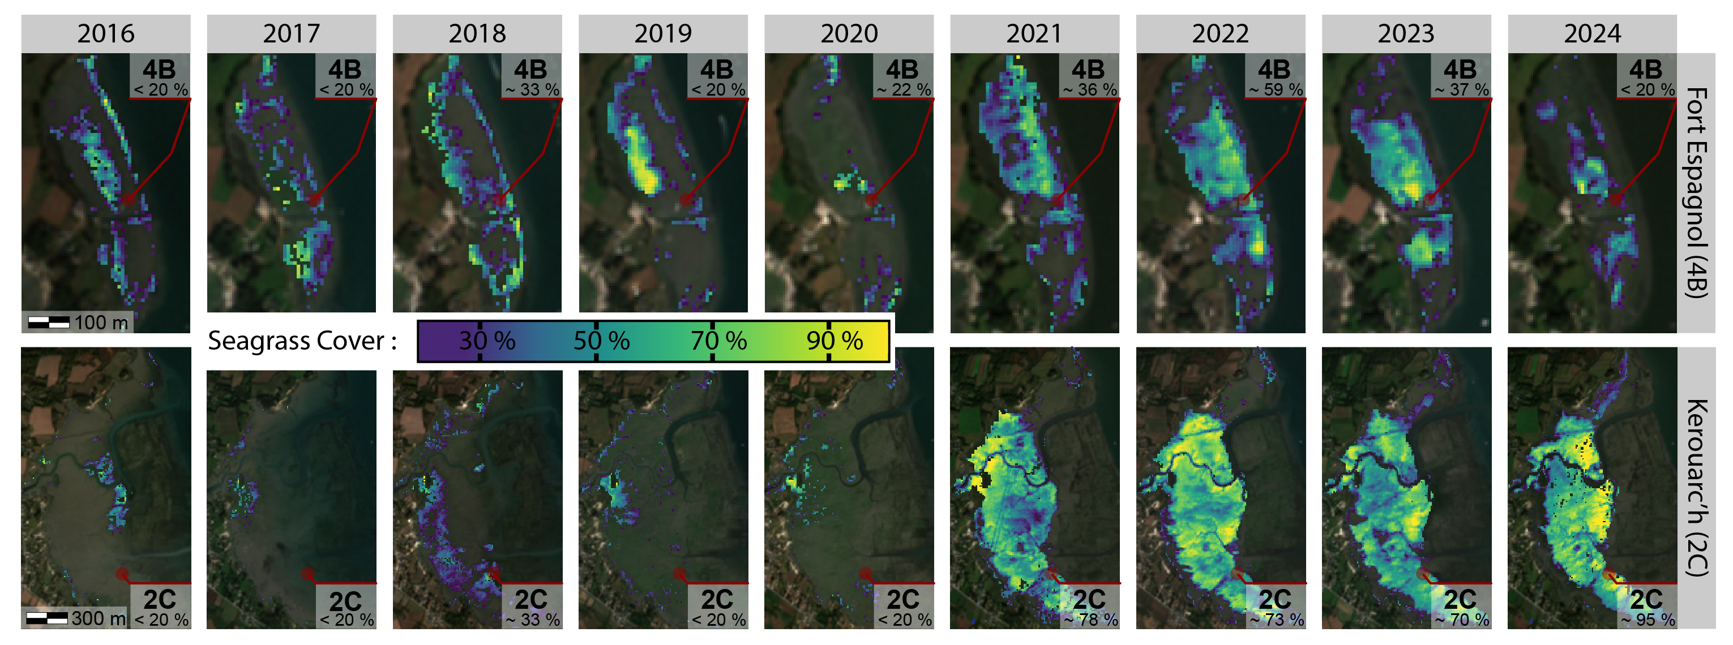
Figure 1: Time Series of Seagrass Percent Cover from 2016 to 2024 in Fort Espagnol and Kerouarc’h, two sites along the Auray River. Red points represent sampling stations: 4B - 47.616°N, 2.953°W; 2C - 47.583°N, 2.955°W. Labels are showing SPC values for each Site/Year.

2.2 Evolution of the extent and density of the meadow over time
Figure 2 A) shows the temporal evolution of seagrass meadow extent at both sites. From 2016 onwards, the extent steadily increased, reaching a maximum in 2021 at Fort Espagnol and in 2022 at Kerouarc’h. The only exception to this trend occurred in 2020, due to the presence of green algae overlaying the meadow, which led to an underestimation of its actual extent in the satellite imagery. After reaching their respective peaks, the extent slightly declined at both locations in the following years.
Figure 2 B) shows the density of meadow over time. Cover remained relatively stable from 2016 to 2020, then increased sharply at both sites, reaching a maximum average of 72% per pixel at Kerouarc’h in 2024 and 54% at Fort Espagnol in 2023. In 2024, however, a marked decline in density is observed at Fort Espagnol, despite the extent of the meadow remaining relatively high.
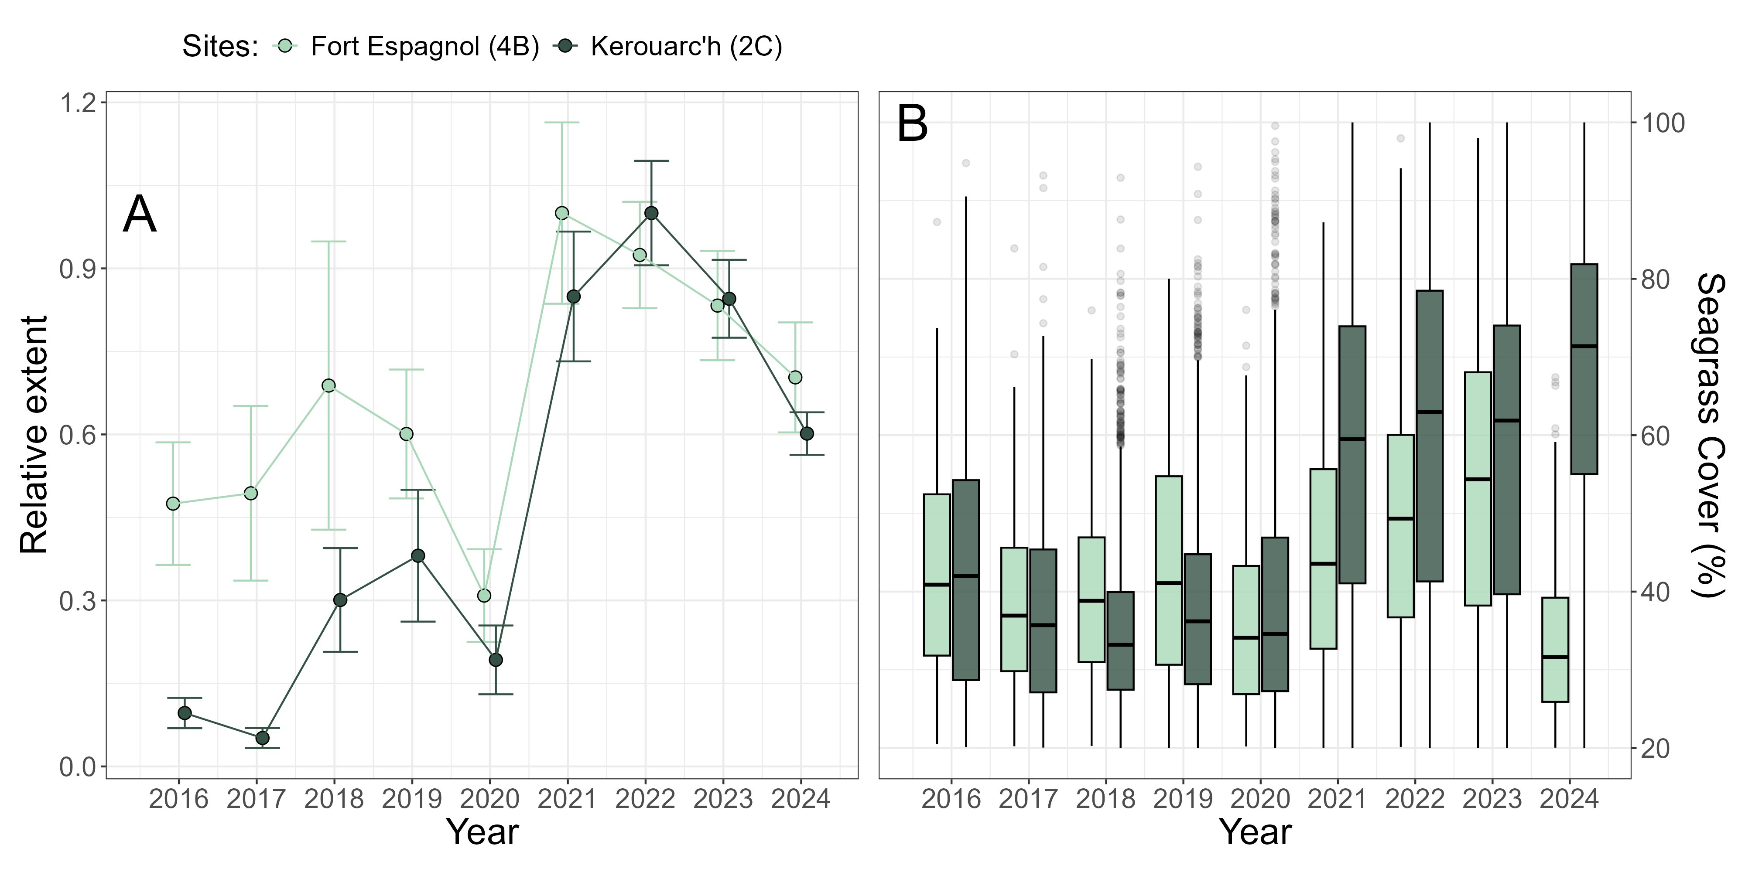
Figure 2: Description of the evolution of seagrass over time. A - Relative seagrass extent of each site. A value of 1 means maximum extent of the time serie for the site. B - Boxplot of the density of seagrass for each site at each date. The lower and upper hinges correspond to the first and third quartiles (the 25th and 75th percentiles). Whiskers are to 1.5 * IQR (Inter-Quartile Range) from the hinge.

2.3 Monthly cover of seagrasses
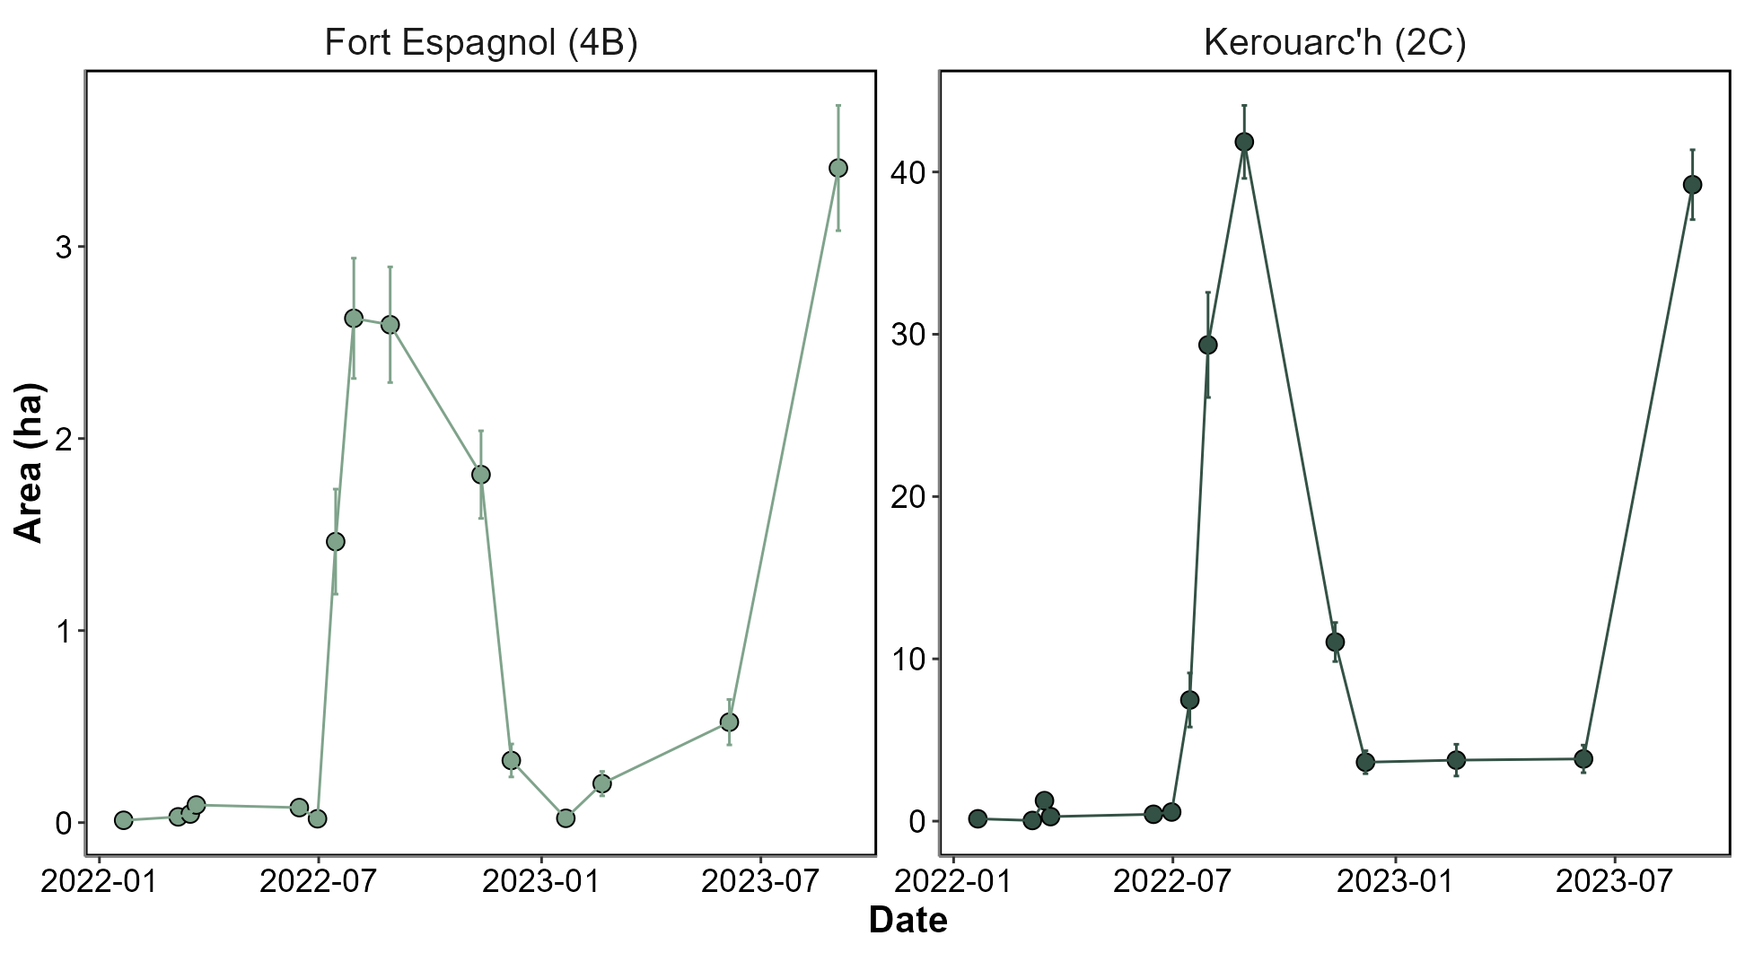
Figure 3: Evolution of the seagrass cover at Fort Espagnol (left) and at Kerouarc’h (right) during 2022 - 2023. Points with error bars show neural network estimated cumulative area and average uncertainty per satellite image.
Figure 3 shows a strong seasonal variation in seagrass cover at both sites. Seagrass cover is nearly absent during winter and begins to increase in early summer (July), reaching peak extent and density around September. Kerouarc’h hosts the largest meadows, covering more than 40 hectares on August 29, 2022, while Fort Espagnol reaches a maximum extent of 2.5 hectares during the same period.
Copernicus. 2024. “Copernicus Open Access Hub.” https://browser.dataspace.copernicus.eu/.
Davies, Bede Ffinian Rowe, Simon Oiry, Philippe Rosa, Maria Laura Zoffoli, Ana I. Sousa, Oliver R. Thomas, Dan A. Smale, et al. 2024. “A Sentinel Watching over Inter-Tidal Seagrass Phenology Across Western Europe and North Africa.” Communications Earth & Environment 5 (1): 382. https://doi.org/10.1038/s43247-024-01543-z.
Hijmans, R. 2023. “Terra: Spatial Data Analysis. R Package Version 1.7-39.” The R Foundation for Statistical Computing.
Rouse, John Wilson, Rüdiger H Haas, John A Schell, Donald W Deering, et al. 1974. “Monitoring Vegetation Systems in the Great Plains with ERTS.” NASA Spec. Publ 351 (1): 309.
Wickham, Hadley. 2017. “Easily Install and Load the ‘Tidyverse’.” R Package Version 1 (1).
Zoffoli, Maria Laura, Pierre Gernez, Philippe Rosa, Anthony Le Bris, Vittorio E Brando, Anne-Laure Barillé, Nicolas Harin, et al. 2020. “Sentinel-2 Remote Sensing of Zostera Noltei-Dominated Intertidal Seagrass Meadows.” Remote Sensing of Environment 251: 112020. https://doi.org/10.1016/j.rse.2020.112020.

